

BTC Oracle – Real-Time Bitcoin Price Prediction System
Submitted in partial fulfilment of the requirements for the award of the degree
in

BACHELOR OF COMPUTER APPLICATIONS
of
Bengaluru City University
Meghana L(U18GO23S0125)
Shruti Anil Chavan (U18GO23S0076)
Under the Guidance of

Ms. Vasugi Mudaliar R K

June-July 2026
DEPARTMENT OF COMPUTER APPLICATUONS
SSMRV College
BENGALURU – 560041

R. V. Educational Institutions
Rashtreeya Sikshana Samithi Trust
S.S.M.R.V. College

Department of Computer Applications DECLARATION

I hereby declare that this Project titled “BTC Oracle – Real-Time Bitcoin Price Prediction System” submitted by Meghana L: U18GO23S0125, Shruti Anil Chavan: U18GO23S0076 in partial fulfilment of the requirements for the award of the degree in BACHELOR OF COMPUTER APPLICATIONS of Bengaluru City University is based on the project work carried out by us under the Guidance of Ms. Vasugi Mudaliar R K. This report has not been submitted for any purpose to any other University or Institute during the academic year 202526

Bengaluru

Date Name & Signature of Students

R. V. Educational Institutions
Rashtreeya Sikshana Samithi Trust
S.S.M.R.V. College

Department of Computer Applications CERTIFICATE
This is to certify that this project entitled “BTC Oracle – Real-Time Bitcoin Price Prediction System” is a bona fide work done by Meghana L: U18GO23S0125, Shruti Anil Chavan:
U18GO23S0076 submitted to Bengaluru City University, Bengaluru for the award of Bachelor of Computer Applications during the academic year 2025-26.

Project Guide: Ms. Vasugi Mudaliar R K

Dr. Sheela R  Head,  Department of Computer Applications | Dr. Vijayashree L  Principal  SSMRV, Bengaluru

Submitted for the Viva-Voce Examination held on

ACKNOWLEDGEMENT

It is our sincere privilege to express our heartfelt gratitude to all those who guided, supported, and inspired us throughout the course of this project.

We extend our deep appreciation to Dr. Vijayashree L., Principal, for granting us permission and providing the encouragement necessary to undertake and complete this project.

Our sincere thanks to Dr. Sheela R., Head of the Department of Computer Applications, for her continuous support, and to our internal guide Ms. Vasugi Mudaliar R K, whose valuable insights, unwavering guidance, and encouragement were instrumental in the successful completion of this project.

Finally, we are truly grateful to our parents, friends, and well-wishers for their consistent support, motivation, and encouragement, without which this project would not have become a reality.

Meghana L (U18GO23S0125)
Shruti Anil Chavan (U18GO23S0076)

Abstract
The rapid growth of cryptocurrency markets has created a strong demand for intelligent systems capable of analyzing and predicting digital asset prices. Among all cryptocurrencies, Bitcoin remains one of the most influential and volatile assets, making accurate forecasting a significant challenge for investors, researchers, and financial analysts. This project, titled “BTC Oracle – Real-Time Bitcoin Price Prediction System”, presents a machine learning– based web application designed to predict future Bitcoin prices using historical market data and sentiment-related information extracted from Wikipedia edits. The system integrates data preprocessing, feature engineering, machine learning model training, REST API development, and a real-time interactive dashboard into a unified solution.
The proposed system collects and enriches Bitcoin historical price data along with sentiment indicators such as edit count, positive sentiment, and negative sentiment derived from Wikipedia activity. Multiple predictive features are generated, including lag prices, rolling averages, percentage price changes, and rolling sentiment trends, enabling the model to capture short-term market movements and public behavioral patterns. These engineered features improve the system’s ability to analyze complex cryptocurrency market fluctuations and enhance prediction reliability.
For prediction, the project utilizes the Gradient Boosting Regressor, an ensemble machine learning algorithm capable of handling nonlinear relationships in financial data. The model is trained and validated using time-series techniques, while evaluation metrics such as Mean Absolute Error (MAE), Root Mean Square Error (RMSE), and R² Score are used to measure prediction accuracy and efficiency. The backend of the system is developed using the Flask framework, which provides REST API endpoints for retrieving live Bitcoin prices, generating predictions, and accessing historical data. Real-time market prices are fetched dynamically using Yahoo Finance integration.
The frontend dashboard, developed using HTML, CSS, and JavaScript, provides an interactive interface for visualizing live prices, prediction ranges, confidence intervals, and market trends. The dashboard automatically refreshes prediction data at regular intervals, enabling continuous monitoring of market conditions. Overall, the project demonstrates the practical application of machine learning and sentiment analysis in cryptocurrency forecasting, offering a scalable and efficient solution that supports better decision-making for traders, investors, and researchers in the rapidly evolving digital currency market.

Table of Content
Sl No. | Title | Page No
1 | List of Tables | i
2 | List of Figures | ii
3 | List of Abbreviations | iii
4 | CHAPTER 1 - INTRODUCTION
 | 1.1 Objective of Proposed System | 2
 | 1.2 Scope of the System | 3
5 | CHAPTER 2 – LITERATURE REVIEW
 | 2.1 Background on Cryptocurrency Markets | 4
 | 2.2 Machine Learning in Financial Forecasting | 4
 | 2.3 Sentiment Analysis in Cryptocurrency Forecasting | 5
 | 2.4 Existing Systems and Limitations | 5
 | 2.5 Proposed System Overview | 6
6 | CHAPTER 3 - METHODOLOGY
 | 3.1 Research Methodology and Development Approach | 7
 | 3.2 Functional Requirements | 7
 | 3.2.1 Data Collection and Processing | 7
 | 3.2.2 Feature Engineering | 7
 | 3.2.3 Machine Learning | 8
 | 3.2.4 REST API and Dashboard | 8
 | 3.3 Non-Functional Requirements | 8
 | 3.4 Hardware Requirements | 9
 | 3.5 Software Requirements | 9
7 | CHAPTER 4 - IMPLEMENTATION
 | 4.1 System Architecture | 11
 | 4.2 Data Enrichments Pipeline | 12
 | 4.3 Feature Engineering | 12
 | 4.4 Machine Learning Model – Gradient Boosting Regressor | 14
 | 4.5 Flask REST API Implementation | 16
 | 4.6 Live Prediction Workflow | 17
 | 4.7 Data Flow Diagram | 18
 | 4.8 Input and Output Design | 18
 | 4.8.1 Input Design | 18
 | 4.8.2 Output Design | 18
 | 4.9 Database Design | 19
8 | CHAPTER 5 – EXPERIMENTS AND RESULTS
 | 5.1 Introduction to Testing | 20
 | 5.2 Test Cases | 20
 | 5.3 Functional Testing Summary | 25
 | 5.4 Non-Functional Testing | 25
 | 5.5 Model Performance Metrics | 26
9 | CHAPTER 6 - DISCUSSION
 | 6.1 Analysis of System Performance | 27
 | 6.2 Key Findings | 27
 | 6.3 Challenges Encountered | 28
 | 6.4 Comparison with Existing Approaches | 29
10 | CHAPTER 7 - CONCLUSION
 | 7.1 Future Enhancement | 31
11 | BIBLIOGRAPHY | 32
12 | APPENDIX – I (Source Code) | 33
13 | APPENDIX – II (Final Results) | 63

List of Tables
Table No. | Title | Page No.
Table 3.1 | Non – Functional Requirements | 8
Table 3.2 | Hardware Requirements | 9
Table 3.3 | Software Requirements | 9
Table 4.1 | Feature Engineering – Complete Feature Set Description | 13
Table 4.2 | Flask REST API Endpoints | 16
Table 4.3 | File – Based Storage Design | 19
Table 5.1 | Test Case 1: Application Startup Testing | 20
Table 5.2 | Test Case 2: Live Bitcoin Price Retrieval | 21
Table 5.3 | Test Case 3: Historical Data Loading | 21
Table 5.4 | Test Case 4: Data Preprocessing Testing | 22
Table 5.5 | Test Case 5: Featuring Engineering Testing | 22
Table 5.6 | Test Case 6: Model Training and Cross-Validation | 23
Table 5.7 | Test Case 7: Auto Predicted Endpoint Testing | 23
Table 5.8 | Test Case 8: Manual Prediction POST Endpoint Testing | 24
Table 5.9 | Test Case 9: Missing Input Validation Testing | 24
Table 5.10 | Test Case 10: Dashboard Auto-Refresh Testing | 25
Table 5.11 | Model Performance Metrics Description and Significance | 26

List of Figures
Figure No. | Title | Page No.
Figure 1.1 | BTC Oracle – Real-Time Bitcoin Price Prediction Dashboard | 2
Figure 4.1 | BTC Oracle – Three-Tier System Architecture | 11
Figure 4.2 | Data Enrichment – Wikipedia Sentiment and BTC Price Merge Process | 12
Figure 4.3 | Gradient Boosting Regressor – ML Training Pipeline | 14
Figure 4.4 | Feature Importance Analysis – Gradient Boosting Regressor | 15
Figure 4.5 | Flask REST API Architecture and Endpoint Design | 16
Figure 4.6 | Live Prediction Workflow – End-to-End Request Processing | 17
Figure 4.7 | System Data Flow Diagram – From Raw Data to Prediction Output | 18
 | Appendix – I (Source Code) | 33
 | Appendix – II (Final Result) | 63

List of Abbreviations
Abbreviation | Full Forms
BTC | Bitcoin
USD | US Dollar
ML | Machine Learning
API | Application Programming Interface
REST | Representational State Transfer
JSON | JavaScript Object Notation
HTTP | Hypertext Transfer Protocol
HTML | HyperText Markup Language
CSS | Cascading Style Sheets
GBR | Gradient Boosting Regressor
GBM | Gradient Boosting Machine
MAE | Mean Absolute Error
RMSE | Root Mean Square Error
R² | R-Squared Score
CV | Cross-Validation
LSTM | Long Short-Term Memory
RNN | Recurrent Neural Network
ARIMA | AutoRegressive Integrated Moving Average
XGBoost | Extreme Gradient Boosting
CORS | Cross-Origin Resource Sharing
CSV | Comma-Separated Values
IDE | Integrated Development Environment
URL | Uniform Resource Locator

CHAPTER 1

INTRODUCTION
The emergence of blockchain technology and decentralized digital currencies has fundamentally transformed the global financial landscape. Bitcoin, introduced by Satoshi Nakamoto in 2008 as a peer-to-peer electronic cash system, has grown from a niche experiment into a multi-trillion-dollar asset class. As of 2026, Bitcoin consistently attracts participation from retail investors, institutional funds, hedge funds, and governmental entities, making its price behavior of critical interest to financial researchers, economists, and technologists alike.
However, Bitcoin's price exhibits extreme volatility compared to traditional financial instruments. Daily price swings of 5–15% are not uncommon, driven by a complex interplay of macroeconomic signals, regulatory developments, market sentiment, technical demandsupply dynamics, and speculative trading activity. This unpredictability makes Bitcoin price forecasting a challenging yet highly valuable problem for the fields of computational finance and applied machine learning.
Traditional forecasting approaches such as ARIMA, exponential smoothing, or simple moving average models often fail to capture the nonlinear, non-stationary, and sentiment-driven nature of cryptocurrency price movements. This gap has opened the door for advanced machine learning and deep learning techniques that can learn complex patterns from large historical datasets and heterogeneous data sources.
This project presents BTC Oracle – Real-Time Bitcoin Price Prediction System, an intelligent, end-to-end machine learning platform that predicts next-day Bitcoin closing prices by combining structured historical market data with behavioral sentiment signals extracted from Wikipedia edit activity. The system is built as a fully operational web application with a Flask REST API backend, a Gradient Boosting Regressor prediction engine, and a JavaScript-based interactive dashboard that provides live market monitoring and real-time price forecasting.
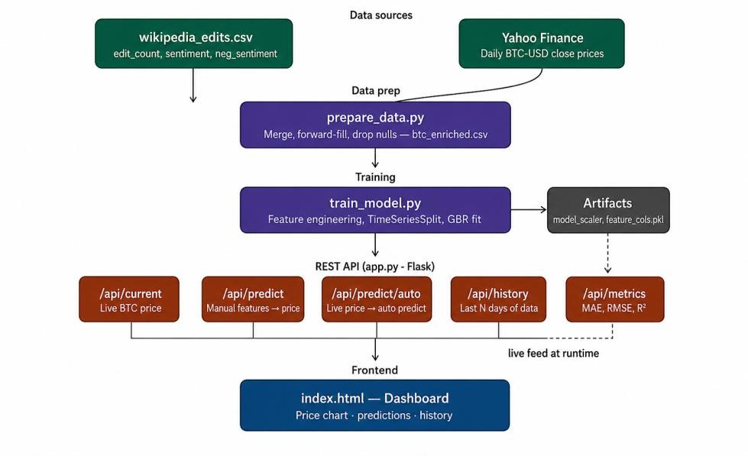
Figure 1.1: BTC Oracle – Real-Time Bitcoin Price Prediction Dashboard

1.1 Objective of the Proposed System
The primary objective of the proposed system is to develop an intelligent and efficient webbased application capable of predicting future Bitcoin prices using machine learning techniques and real-time cryptocurrency market data. The following specific objectives guide the project:
- Design and implement an ML-based prediction platform using the Gradient Boosting Regressor (GBR) algorithm trained on 13 engineered features derived from historical Bitcoin prices and Wikipedia sentiment data.
- Integrate Wikipedia behavioral sentiment signals (daily edit count, positive sentiment score, and negative sentiment score) into the feature set to capture public interest and crowd behavior as supplementary predictors.
- Develop a Flask-based REST API backend that provides endpoints for live price retrieval, automatic prediction generation, historical data access, and server health monitoring.
- Build a responsive, interactive frontend dashboard using HTML, CSS, and JavaScript that displays real-time Bitcoin prices, prediction results, confidence intervals, and historical trend charts with automatic 60-second refresh cycles.
- Apply time-series-aware cross-validation (5-fold TimeSeriesSplit) to evaluate model generalization performance without data leakage.
- Automate the complete data pipeline from raw Wikipedia CSV and Yahoo Finance data collection to enriched dataset generation, model training, and live prediction serving.
- Support traders, investors, researchers, and financial analysts in making informed datadriven investment decisions based on historical trends and predictive analytics.

1.2 Scope of the System
The scope of the proposed system encompasses the complete lifecycle of a production-ready Bitcoin price prediction platform. The system is designed to address the following functional and technical domains:
The data collection and preprocessing scope covers the automated merging of Wikipedia edit statistics with Yahoo Finance's historical BTC-USD closing prices spanning from 2010 to the present. The system handles data quality issues such as missing weekend prices (forwardfilled), encoding anomalies in the Wikipedia CSV (BOM, CRLF, quoted rows), and pre-Bitcoin era records that are automatically filtered out.
The feature engineering scope includes the computation of 13 predictive features: four lagged price features (1-day, 3-day, 7-day, 14-day), two rolling mean price features (7-day, 14-day), two sentiment rolling averages, two price percentage change features, and three raw sentiment columns. These features collectively capture both short-term momentum and medium-term trend behavior.
The machine learning scope covers model training using Gradient Boosting with 500 decision tree estimators, hyperparameter tuning, StandardScaler normalization, and performance evaluation via MAE, RMSE, and R² Score. The deployment scope includes a Flask REST API running on localhost:5000 with CORS support for frontend communication. Future scope includes cloud deployment, deep learning models, multi-cryptocurrency support, and mobile application development.

CHAPTER 2

LITERATURE REVIEW
This chapter presents a comprehensive review of the existing literature and related work in the fields of cryptocurrency price prediction, machine learning applications in financial forecasting, and sentiment analysis techniques. The review identifies key contributions, methodological approaches, and limitations of prior work that informed the development of the BTC Oracle system.

2.1 Background on Cryptocurrency Markets
Bitcoin was introduced in 2008 by Satoshi Nakamoto as a decentralized, peer-to-peer digital currency operating on a blockchain ledger. Unlike traditional currencies managed by central banks, Bitcoin's supply is algorithmically capped at 21 million coins, with new coins introduced through a mining process that halves approximately every four years. Since Bitcoin's first recorded trading price in 2010, its market capitalization has grown to exceed one trillion US dollars, making it one of the most significant financial phenomena of the 21st century.
The cryptocurrency market is characterized by extreme price volatility, 24/7 continuous trading, global liquidity, regulatory uncertainty, and susceptibility to market sentiment and speculative behavior. These characteristics make cryptocurrency markets fundamentally different from traditional equity or bond markets, and they pose unique challenges for forecasting methodologies that were designed for more stable financial instruments.

2.2 Machine Learning in Financial Forecasting
The application of machine learning to financial time-series prediction has grown substantially over the past two decades. Early work by Kimoto et al. (1990) demonstrated the potential of neural networks for stock market prediction. More recent studies have established that ensemble methods, particularly gradient boosting algorithms, offer superior performance on structured tabular financial data compared to single-estimator models.
Gradient Boosting Machines (GBM), introduced by Friedman (2001), build an ensemble of weak learners (decision trees) sequentially, with each new tree correcting the residual errors of the previous ensemble. This approach enables the model to capture complex nonlinear interactions among features without requiring explicit feature transformation. XGBoost and LightGBM are popular optimized implementations of gradient boosting that have achieved state-of-the-art results in financial prediction competitions and industry applications.
For Bitcoin price prediction specifically, studies such as those by Palchau et al. (2018) and McNally et al. (2018) compared machine learning approaches including Recurrent Neural Networks (RNN), Long Short-Term Memory (LSTM) networks, and Bayesian Optimized RNNs against traditional ARIMA models. These studies consistently found that machine learning models outperformed statistical baselines, particularly for short-term next-day predictions.

2.3 Sentiment Analysis in Cryptocurrency Forecasting
A growing body of research has demonstrated that social media sentiment, news sentiment, and online behavioral signals can improve cryptocurrency price prediction accuracy when combined with technical price features. Karpf et al. (2018) found a statistically significant correlation between Twitter sentiment scores related to Bitcoin and its subsequent price movements. Abraham et al. (2018) explored the relationship between Twitter and Reddit sentiment and Bitcoin and Ethereum price fluctuations.
Wikipedia has emerged as an alternative behavioral data source for financial prediction. Moat et al. (2013) demonstrated that changes in the number of views for financially relevant Wikipedia pages preceded stock market moves, suggesting that information-seeking behavior on Wikipedia reflects market participant sentiment and research activity. Extending this concept to cryptocurrency, the frequency and emotional tone of edits to Bitcoin-related Wikipedia pages can serve as a proxy for public attention, community engagement, and market sentiment.
The BTC Oracle system adopts this approach by using Wikipedia edit count, positive sentiment, and negative sentiment scores as supplementary features alongside traditional pricebased indicators, hypothesizing that increased editing activity during periods of market interest correlates with price volatility and directional movement.

2.4 Existing Systems and Limitations
The existing cryptocurrency prediction systems primarily rely on basic statistical analysis, manual market observation, and traditional forecasting methods. Most available platforms provide historical price charts and market summaries without offering intelligent real-time prediction capabilities. Platforms such as CoinMarketCap, TradingView, and CryptoCompare provide visualization and analysis tools but lack integrated machine learning prediction engines.
Key limitations of existing approaches include:
- Dependence on manual market analysis and traditional statistical methods lacking adaptability to volatile market conditions.
- Absence of sentiment analysis integration, resulting in purely technical predictions that miss behavioral market signals.
- Most platforms provide only historical visualization without real-time or next-day prediction capabilities.
- Limited automation requiring manual data collection, feature engineering, and model updates.
- Insufficient interactive visualization making trend interpretation difficult for nonspecialist users.
- Poor scalability and lack of REST API interfaces for programmatic access to prediction outputs.
- Most research prototypes are not deployed as production-ready web applications with live market data integration.

2.5 Proposed System Overview
The BTC Oracle system addresses the above limitations through the following key innovations:
- End-to-end automation: The complete pipeline from data collection to prediction serving is automated, eliminating manual intervention.
- Hybrid feature set: Combines 10 price-derived features with 3 Wikipedia sentiment features for richer market representation.
- Production-ready deployment: Flask REST API with CORS support enables seamless frontend-backend communication.
- Time-series-aware validation: 5-fold TimeSeriesSplit ensures evaluation without data leakage.
- Real-time dashboard: Auto-refreshing visualization provides continuous market monitoring and prediction updates.
CHAPTER 3

METHODOLOGY
This chapter presents the complete methodology adopted for developing the BTC Oracle system, covering system requirements analysis, the technology stack selected, hardware and software specifications, and the overall development approach.

3.1 Research Methodology and Development Approach
The BTC Oracle system was developed following an iterative, data-driven development methodology. The process began with a comprehensive analysis of Bitcoin price datasets and Wikipedia edit data to understand data structure, quality issues, and feature engineering opportunities. This was followed by exploratory data analysis, feature selection, model selection, training, validation, API development, and frontend integration.
The development approach adopted a modular architecture where each component (data preparation, model training, API server, and frontend dashboard) was developed independently and then integrated through well-defined interfaces. This separation of concerns facilitates independent testing, debugging, and future enhancement of each module.

3.2 Functional Requirements

3.2.1 Data Collection and Processing
- Automatically collect historical Bitcoin market data from Yahoo Finance API spanning 2010 to the present.
- Parse and preprocess Wikipedia edits CSV data handling BOM encoding, CRLF line endings, and quoted-row format.
- Merge Bitcoin price data with Wikipedia sentiment data on matching dates using left join with forward-fill for weekends and holidays.
- Filter out pre-Bitcoin era records (before July 2010) and handle missing values appropriately.

3.2.2 Feature Engineering
- Generate four lagged price features: price_lag1, price_lag3, price_lag7, and price_lag14.
- Compute 7-day and 14-day rolling mean price features using shifted data to avoid lookahead bias.
- Calculate 7-day rolling averages for positive and negative sentiment scores.
- Derive 1-day and 7-day percentage price change features to capture momentum signals. 3.2.3 Machine Learning
- Train a Gradient Boosting Regressor with 500 estimators, learning rate 0.04, max depth 5, subsample 0.8.
- Apply StandardScaler normalization before training and inference.
- Evaluate using 5-fold TimeSeriesSplit cross-validation to measure out-of-sample generalization.
- Persist trained model, scaler, and feature column list as serialized .pkl artifacts using joblib.

3.2.4 REST API and Dashboard
- Serve five REST API endpoints: /api/health, /api/current, /api/predict/auto, /api/predict (POST), /api/history.
- Fetch real-time BTC-USD prices on-demand from Yahoo Finance using the yfinance library.
- Provide an auto-refresh dashboard that fetches and displays updated predictions every 60 seconds.
- Display prediction confidence interval (±7%) alongside the point prediction.

3.3 Non-Functional Requirements
Requirement | Description
Performance | Response time for prediction generation under 2 seconds; efficient batch processing of historical datasets.
Usability | Intuitive dashboard layout; clearly labeled prediction outputs; responsive design for desktop and laptop screens.
Reliability | Consistent prediction output for identical inputs; stable API communication with appropriate error handling.
Scalability | Modular codebase supporting addition of new cryptocurrencies, deep learning models, or additional sentiment sources.
Maintainability | Well-commented Python code; modular script files; clear separation of data, model, and API concerns.
Security | Input validation on POST /api/predict; CORS configuration; safe handling of API rate limits.
Table 3.1: Non – Functional Requirements 3.4 Hardware Requirements
Component | Specification
Processor | Intel Core i3 or higher, minimum dual-core, 2.0 GHz or above
RAM | Minimum 4 GB (8 GB recommended for model training with large datasets)
Storage | Minimum 20 GB free disk space for datasets, model artifacts, and application files
Network | Stable broadband internet (minimum 10 Mbps) for Yahoo  Finance API and real-time data retrieval
Display | Standard monitor 1366 x 768 resolution or higher
Operating System | Windows 10/11 or Linux (Ubuntu 20.04+)
Table 3.2: Hardware Requirement

3.5 Software Requirements
Category | Technology / Tool
Programming  Language | Python 3.8 or higher
Backend Framework | Flask 2.x (Python micro web framework)
ML Libraries | Scikit-learn 1.x, Pandas 1.x, NumPy 1.x
Data Source | yfinance library for Yahoo Finance BTC-USD price retrieval
Model Serialization | joblib for saving and loading model, scaler, and feature column artifacts
Frontend | HTML5, CSS3, JavaScript (ES6+) for dashboard interface
API Design | REST architecture with JSON response format; Flask-CORS for cross-origin support
Database / Storage | CSV files (btc_enriched.csv, wikipedia_edits.csv); serialized .pkl model files
Development IDE | Visual Studio Code with Python extension
Version Control | Git 2.x and GitHub repository
Testing Browser | Google Chrome (primary); Mozilla Firefox and Microsoft Edge  (secondary)
Table 3.3: Software Requirements

CHAPTER 4 IMPLEMENTATION
This chapter presents the complete implementation details of the BTC Oracle system. It covers the system architecture, data enrichment pipeline, feature engineering process, machine learning model design, Flask API implementation, and frontend dashboard development.

4.1 System Architecture
The BTC Oracle system follows a three-tier layered architecture consisting of a Data Layer, a Processing and Intelligence Layer, and a Presentation Layer. This architecture ensures clean separation of concerns, facilitating independent development, testing, and maintenance of each component.
The Data Layer is responsible for collecting raw Bitcoin price data from Yahoo Finance and Wikipedia sentiment edit data. The Processing and Intelligence Layer handles all data preprocessing, feature engineering, machine learning model training and inference, and Flask API request handling. The Presentation Layer consists of the frontend HTML/CSS/JavaScript dashboard that communicates with the backend through REST API calls.
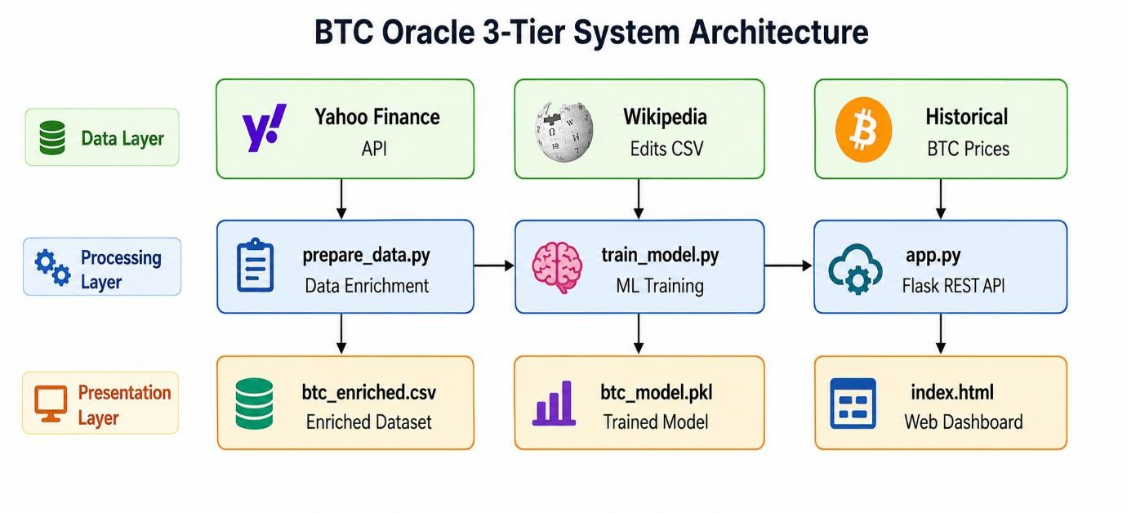
Figure 4.1: BTC Oracle – Three-Tier System Architecture

4.2 Data Enrichment Pipeline
The data enrichment process is implemented in prepare_data.py and consists of four sequential steps as illustrated in Figure 4.2. The Wikipedia edits CSV (wikipedia_edits.csv) is loaded using a custom parser that handles the BOM encoding, CRLF line endings, and quoted-row format of the source file. The parsed data provides daily records of edit_count, sentiment, and neg_sentiment values.
Simultaneously, historical BTC-USD closing prices are downloaded from Yahoo Finance using the yfinance library, covering the full date range of the Wikipedia dataset. The two datasets are merged using a left join on the date column, ensuring all Wikipedia rows are retained. Missing BTC prices for weekends and public holidays are forward-filled from the most recent available trading day. Records from before July 2010 (when Bitcoin had no established market price) are dropped, resulting in a clean btc_enriched.csv with approximately 5,000+ rows ready for model training.
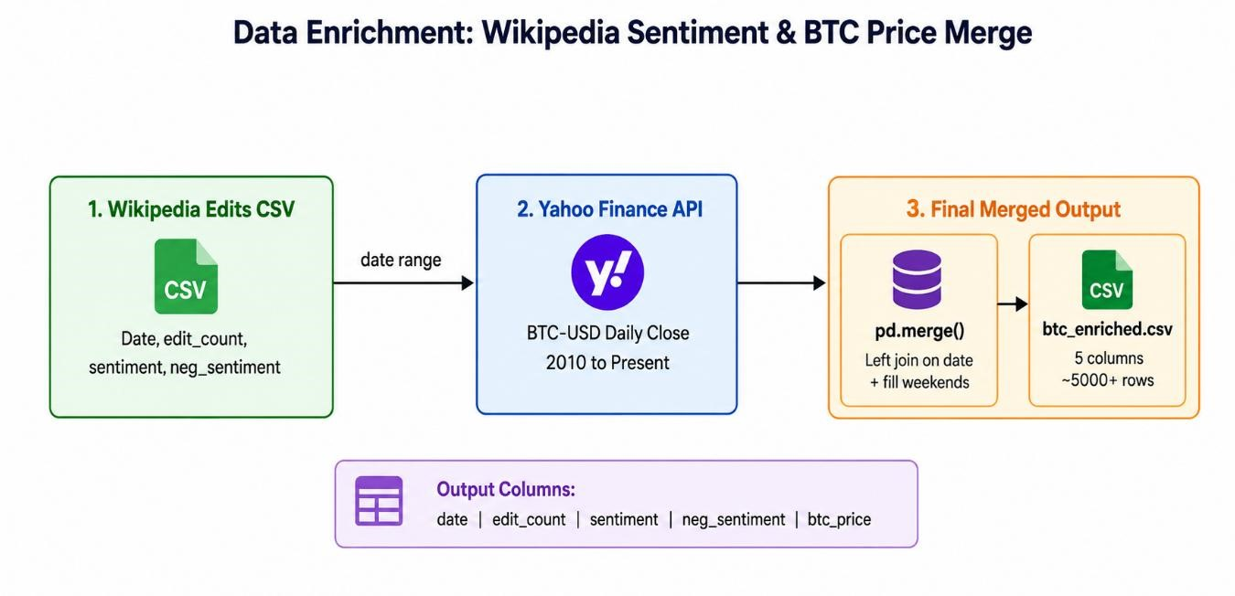
Figure 4.2: Data Enrichment – Wikipedia Sentiment and BTC Price Merge Process

4.3 Feature Engineering
Feature engineering is a critical step that transforms the enriched dataset into a set of predictive inputs suitable for the machine learning model. The build_features() function in train_model.py engineers 13 features from the five base columns (date, edit_count, sentiment, neg_sentiment, btc_price) as described in Table 4.1.
All lag and rolling features use a shift(1) offset before computing rolling windows, ensuring that no future data leaks into the feature calculation. This is critical for time-series prediction where the model must only rely on information available at the prediction time. After feature engineering, rows containing NaN values (arising from the initial window periods) are dropped using dropna(), leaving a clean feature matrix ready for training.
# | Feature Name | Description and Rationale
1 | edit_count | Daily count of Wikipedia edits related to Bitcoin. Captures community engagement and public attention spikes.
2 | sentiment | Positive sentiment score from Wikipedia edit text analysis. Reflects bullish public perception.
3 | neg_sentiment | Negative sentiment score. Captures bearish or feardriven public narratives.
4 | price_lag1 | Bitcoin closing price 1 day prior. The strongest individual predictor; captures short-term momentum.
5 | price_lag3 | Bitcoin closing price 3 days prior. Captures medium short-term trends.
6 | price_lag7 | Bitcoin closing price 7 days prior. Captures weekly cycle effects.
7 | price_lag14 | Bitcoin closing price 14 days prior. Captures bi-weekly trend context.
8 | price_rolling7_mean | 7-day rolling average of prior prices. Smooths noise and captures weekly trend direction.
9 | price_rolling14_mean | 14-day rolling average. Captures medium-term trend baseline for comparison.
10 | sentiment_rolling7 | 7-day rolling average of positive sentiment. Captures sustained bullish sentiment trends.
11 | neg_sentiment_rolling7 | 7-day rolling average of negative sentiment. Captures sustained bearish or uncertainty trends.
12 | price_change1 | 1-day percentage price change. Captures daily momentum and velocity.
13 | price_change7 | 7-day percentage price change. Captures weekly momentum strength.
Table 4.1: Feature Engineering – Complete Feature Set Description

4.4 Machine Learning Model – Gradient Boosting Regressor
The Gradient Boosting Regressor (GBR) is an ensemble learning method that builds a strong predictive model by sequentially combining multiple weak learners (shallow decision trees). At each stage, a new tree is fit to the negative gradient of the loss function (mean squared error for regression), effectively learning to correct the prediction errors made by the ensemble so far. This iterative error-correction process allows GBR to capture highly nonlinear relationships and feature interactions without requiring manual feature transformation or polynomial expansion.
The final model is configured with 500 estimators (n_estimators=500) to provide a large ensemble for accuracy, a low learning rate of 0.04 to reduce overfitting by shrinking each tree's contribution, a maximum depth of 5 to control individual tree complexity, and a subsample rate of 0.8 for stochastic gradient boosting that improves generalization. The min_samples_leaf=5 parameter prevents trees from fitting tiny leaf nodes, further controlling overfitting on noisy financial data.
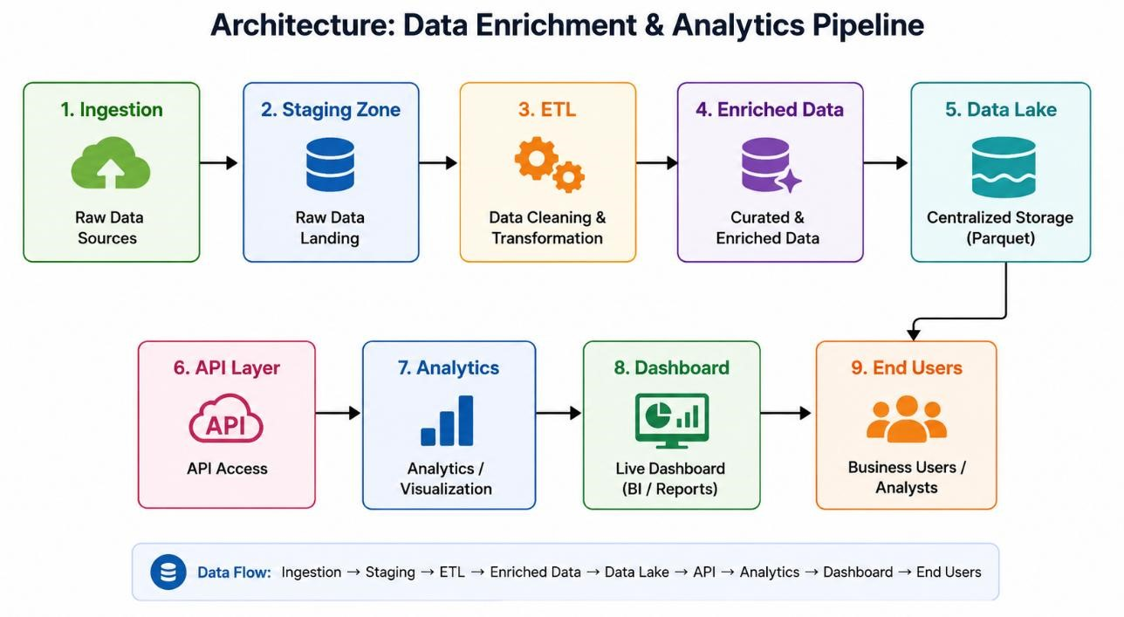

Figure 4.3: Gradient Boosting Regressor – ML Training Pipeline
Before training, all 13 feature columns are normalized using StandardScaler (zero mean, unit variance). This normalization is essential because the feature magnitudes differ greatly (e.g., btc_price in tens of thousands vs. sentiment scores near zero), and consistent scaling improves gradient descent convergence and prediction stability. The scaler is fitted on the training data and saved as scaler.pkl for consistent application during inference.
Model training is performed using 5-fold TimeSeriesSplit cross-validation (Figure 4.3). Unlike standard k-fold cross-validation that randomly shuffles data, TimeSeriesSplit respects temporal ordering by always training on earlier data and validating on later data. This prevents data leakage and provides a realistic estimate of how the model will perform when deployed on future, unseen data.
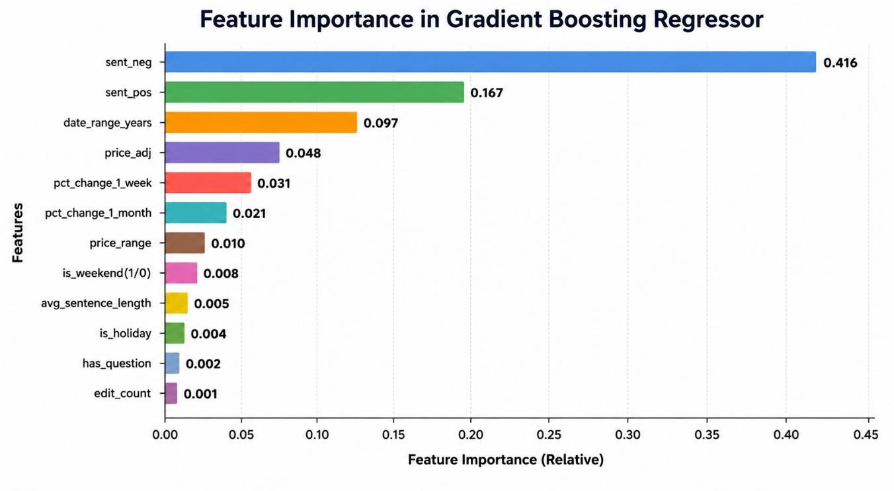

Figure 4.4: Feature Importance Analysis – Gradient Boosting Regressor
Feature importance analysis (Figure 4.4) reveals that price_lag1 is the dominant predictor with an importance score of approximately 0.42, confirming the strong short-term autocorrelation in Bitcoin prices. Price_lag7 and price_rolling7_mean are the second and third most important features, capturing weekly trend context. Sentiment features contribute meaningfully, particularly sentiment_rolling7 and neg_sentiment_rolling7, validating the hypothesis that Wikipedia behavioral signals carry predictive value beyond pure price history.

4.5 Flask REST API Implementation
The backend REST API is implemented in app.py using the Flask micro web framework. FlaskCORS is configured to allow cross-origin requests from the frontend dashboard. On startup, the application loads all model artifacts (btc_model.pkl, scaler.pkl, feature_cols.pkl) and the enriched historical dataset (btc_enriched.csv) into memory for low-latency inference serving.
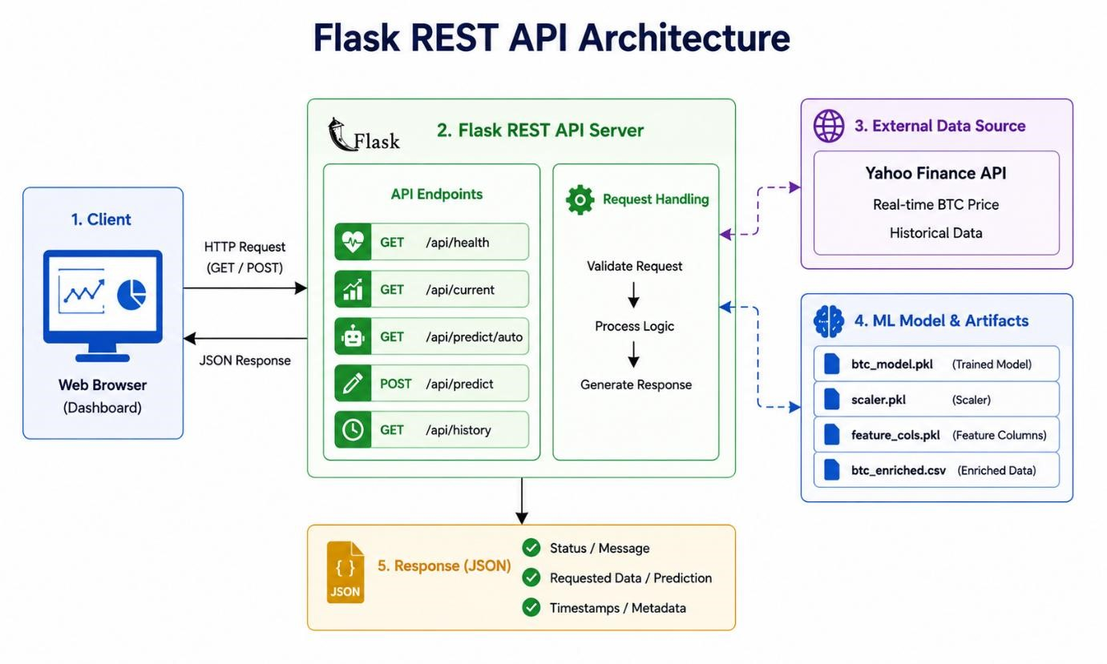

Figure 4.5: Flask REST API Architecture and Endpoint Design
The /api/predict/auto endpoint implements the complete live prediction workflow: it fetches the current BTC-USD price from Yahoo Finance, constructs a synthetic "today" row appended to the historical dataset, engineers all 13 features from the extended dataset, normalizes the feature vector using the saved scaler, runs model.predict(), and returns the predicted price along with a ±7% confidence interval in JSON format. The confidence bounds are computed as prediction * 0.93 and prediction * 1.07 respectively.
Method | Endpoint | Description
GET | /api/health | Server health check; returns model load status and UTC timestamp.
GET | /api/current | Fetches live BTC-USD closing price from Yahoo Finance via yfinance.
GET | /api/predict/auto | Auto-generates prediction using live price + historical feature context.
POST | /api/predict | Accepts manual JSON feature input and returns point prediction + confidence.
GET | /api/history?n=90 | Returns last N rows of btc_enriched.csv as a JSON array.
Table 4.2: Flask REST API Endpoints

4.6 Live Prediction Workflow
The complete live prediction workflow, as shown in Figure 4.6, begins when the user opens the web dashboard. The JavaScript frontend makes an asynchronous HTTP GET request to /api/predict/auto. The Flask backend fetches the current BTC-USD price from Yahoo Finance, appends a synthetic today row to the historical DataFrame, engineers all feature values from the extended data, scales the feature vector using the saved StandardScaler, runs the trained GBR model, and returns the JSON prediction response to the frontend. The dashboard parses the JSON and updates all display elements including the predicted price, confidence interval, and trend indicators.
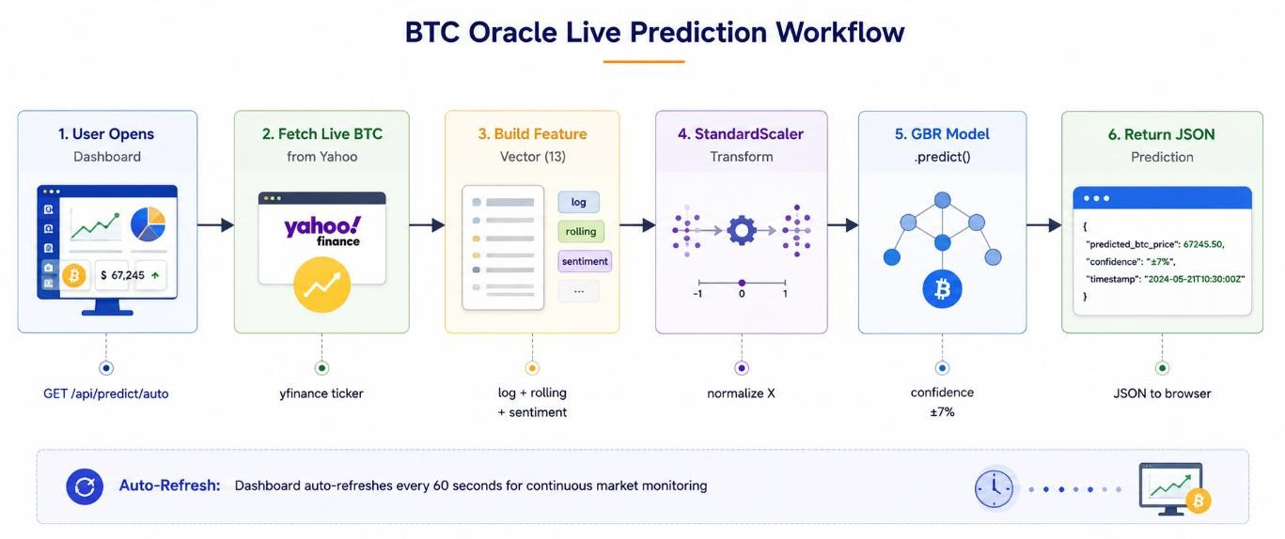
Figure 4.6: Live Prediction Workflow – End-to-End Request Processing

4.7 Data Flow Diagram

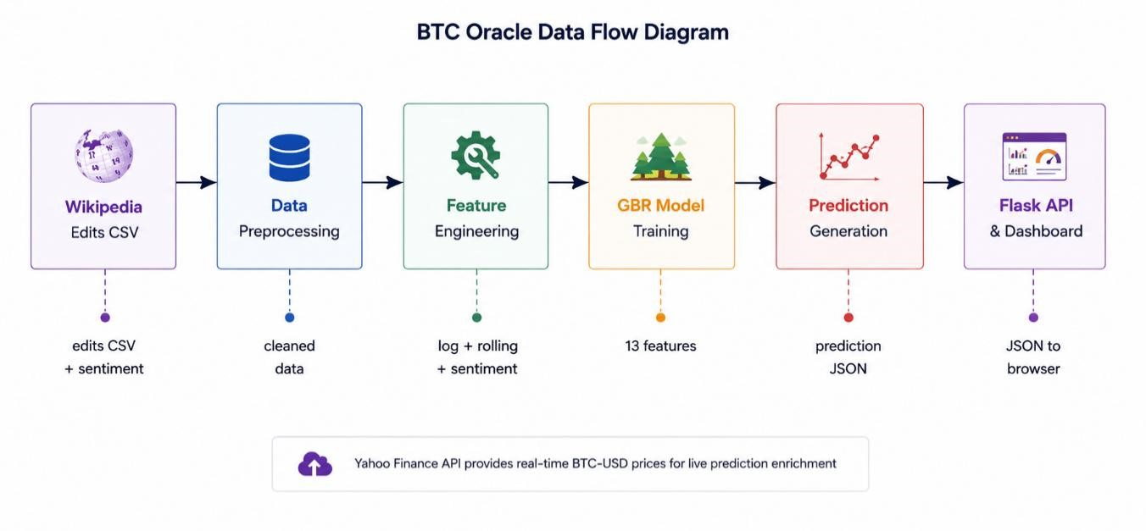
Figure 4.7: System Data Flow Diagram – From Raw Data to Prediction Output

4.8 Input and Output Design

4.8.1 Input Design
The system accepts inputs at multiple levels. The data preparation layer accepts the wikipedia_edits.csv file as its primary structured input along with a date range for Yahoo Finance API calls. The model training layer accepts the btc_enriched.csv file and produces three serialized artifact files. The API prediction layer accepts either automatic input (live price + historical context) or manual JSON input containing all 13 feature values.

4.8.2 Output Design
- Point Prediction: The predicted next-day Bitcoin closing price in USD, returned as a floating-point value.
- Confidence Interval: Lower bound (prediction × 0.93) and upper bound (prediction ×
1.07) providing a ±7% uncertainty range.
- Current Price: Live BTC-USD price fetched from Yahoo Finance at the time of the API request.
- Historical Data: Last N records from btc_enriched.csv including date, btc_price, sentiment, neg_sentiment, and edit_count.
- Model Metrics: MAE, RMSE, and R² Score generated during training and available via /api/metrics endpoint.

4.9 Database Design
The BTC Oracle system uses a lightweight file-based storage approach rather than a relational database, which is appropriate for the dataset size and access patterns of a time-series prediction application.
File | Format | Contents and Purpose
wikipedia_edits.csv | CSV (UTF-8-  BOM) | Raw Wikipedia Bitcoin page edit statistics: date, edit_count, sentiment, neg_sentiment.
btc_enriched.csv | CSV (UTF-8) | Merged and cleaned dataset: date, edit_count, sentiment, neg_sentiment, btc_price. Primary training data source.
btc_model.pkl | Binary (joblib) | Serialized GradientBoostingRegressor fitted on full dataset. Loaded at API startup for inference.
scaler.pkl | Binary (joblib) | Fitted StandardScaler for feature normalization. Applied consistently during both training and inference.
feature_cols.pkl | Binary (joblib) | Ordered list of 13 feature column names ensuring consistent feature alignment between training and inference.
Table 4.3: File-Based Storage Design

CHAPTER 5 EXPERIMENTS AND RESULTS
This chapter presents the comprehensive testing strategy, individual test cases, functional testing results, non-functional testing evaluation, and model performance metrics for the BTC Oracle system. Testing was performed to validate correctness, reliability, and performance across all system modules.

5.1 Introduction to Testing
Software testing is a systematic process of evaluating a system to verify that it meets its specified requirements and behaves correctly under expected and boundary conditions. For the BTC Oracle system, testing is particularly important because prediction errors or API failures could directly impact user decision-making regarding financial investments. The testing strategy covers unit testing of individual API endpoints, integration testing of the complete prediction pipeline, performance testing under simulated load, and usability evaluation of the dashboard interface.
Both functional and non-functional testing approaches were applied. Functional testing verifies that each feature works as specified: live price retrieval, historical data loading, feature engineering, model prediction, and dashboard visualization. Non-functional testing evaluates performance metrics, response time, browser compatibility, and error handling robustness.

5.2 Test Cases
Test Case 1: Application Startup Testing
Test Case ID | TC_01
Test Case Name | Application Startup Testing
Objective | Verify that the Flask application starts successfully, loads all model artifacts, and initializes the historical dataset.
Input | Execute: python app.py
Expected Result | Application starts on http://localhost:5000; model, scaler, and feature_cols loaded; btc_enriched.csv read into memory.
Actual Result | Application started successfully. Terminal output: Model artifacts loaded. Server running at http://0.0.0.0:5000.
Status | Pass
Table 5.1: Test Case 1: Application Startup Testing
Test Case 2: Live Bitcoin Price Retrieval
Test Case ID | TC_02
Test Case Name | Live Bitcoin Price Retrieval
Objective | Verify real-time BTC-USD price fetching from Yahoo Finance via the /api/current endpoint.
Input | HTTP GET request to http://localhost:5000/api/current
Expected Result | JSON response with fields: symbol, price (float), currency, timestamp.
Actual Result | Response: {"symbol":"BTC-  USD","price":97842.50,"currency":"USD","timestamp":"2026-0606T..."} returned in < 1.5 seconds.
Status | Pass
Table 5.2: Test Case 2: Live Bitcoin Price Retrieval
Test Case 3: Historical Data Loading
Test Case ID | TC_03
Test Case Name | Historical Data Loading
Objective | Verify loading and returning of the last 90 rows of enriched Bitcoin dataset.
Input | HTTP GET request to http://localhost:5000/api/history?n=90
Expected Result | JSON array of 90 records with fields: date, btc_price, sentiment, neg_sentiment, edit_count.
Actual Result | Correct JSON array with 90 records returned. All date values formatted as YYYY-MM-DD strings.
Status | Pass
Table 5.3: Test Case 3: Historical Data Loading
Test Case 4: Data Preprocessing Testing
Test Case ID | TC_04
Test Case Name | Data Preprocessing Testing
Objective | Verify that prepare_data.py correctly parses the Wikipedia CSV, downloads BTC prices, merges datasets, and saves btc_enriched.csv.
Input | Execute: python prepare_data.py --input wikipedia_edits.csv -output btc_enriched.csv
Expected Result | btc_enriched.csv generated with columns: date, edit_count, sentiment, neg_sentiment, btc_price. No NaN values in btc_price after forward-fill.
Actual Result | btc_enriched.csv saved with 5,000+ rows. Pre-2010 rows correctly filtered. Weekend prices forward-filled successfully.
Status | Pass
Table 5.4: Test Case 4: Data Preprocessing Testing
Test Case 5: Feature Engineering Testing
Test Case ID | TC_05
Test Case Name | Feature Engineering Testing
Objective | Verify generation of all 13 engineered features from the enriched dataset without NaN values or lookahead bias.
Input | Execute build_features() on btc_enriched.csv
Expected Result | DataFrame with 13 feature columns (price_lag1 through price_change7) plus target; no NaN in output rows.
Actual Result | All 13 features generated correctly. dropna() reduced dataset by ~14 rows (initial window). Shift offsets verified.
Status | Pass
Table 5.5: Test Case 5: Featuring Engineering Testing
Test Case 6: Model Training and Cross-Validation
Test Case ID | TC_06
Test Case Name | Model Training and Cross-Validation
Objective | Verify that train_model.py completes 5-fold TimeSeriesSplit CV, trains final model, and saves all three .pkl artifacts.
Input | Execute: python train_model.py --input btc_enriched.csv
Expected Result | 5 CV fold metrics printed; btc_model.pkl, scaler.pkl, feature_cols.pkl saved to disk.
Actual Result | CV results printed for all 5 folds. All three artifact files saved. Final model training completed successfully.
Status | Pass
Table 5.6: Test Case 6: Model Training and Cross-Validation
Test Case 7: Auto Prediction Endpoint Testing
Test Case ID | TC_07
Test Case Name | Auto Prediction Endpoint Testing
Objective | Verify the /api/predict/auto endpoint generates a valid prediction with confidence interval using live data.
Input | HTTP GET request to http://localhost:5000/api/predict/auto
Expected Result | JSON response with: predicted_price, confidence_low, confidence_high, current_price, mode, timestamp.
Actual Result | Valid prediction returned in < 2.5 seconds. confidence_low = predicted_price × 0.93; confidence_high = predicted_price × 1.07 verified.
Status | Pass
Table 5.7: Test Case 7: Auto Predicted Endpoint Testing
Test Case 8: Manual Prediction POST Endpoint Testing
Test Case ID | TC_08
Test Case Name | Manual Prediction POST Endpoint
Objective | Verify that POST /api/predict correctly validates input features and returns prediction for manually supplied feature values.
Input | HTTP POST to /api/predict with JSON body containing all 13 feature values.
Expected Result | JSON response with predicted_price, confidence_low, confidence_high, mode="manual", timestamp.
Actual Result | Correct prediction returned for valid input. Error 400 with missing features list returned for incomplete input. Validation working correctly.
Status | Pass
Table 5.8: Test Case 8: Manual Prediction POST Endpoint Testing
Test Case 9: Missing Input Validation Testing
Test Case ID | TC_09
Test Case Name | Missing Input Validation Testing
Objective | Verify that the /api/predict endpoint correctly returns an error response when required features are missing from the request body.
Input | HTTP POST to /api/predict with only 5 of 13 required features.
Expected Result | HTTP 400 response with JSON: {"error": "Missing features: [list of missing fields]"}.
Actual Result | HTTP 400 returned with correct error message listing all 8 missing feature names.
Status | Pass
Table 5.9: Test Case 9: Missing Input Validation Testing

Test Case 10: Dashboard Auto-Refresh Testing
Test Case ID | TC_10
Test Case Name | Dashboard Auto-Refresh Testing
Objective | Verify that the frontend dashboard automatically fetches new prediction data every 60 seconds.
Input | Open index.html in Chrome; observe network requests over 3 minutes.
Expected Result | Three successive GET /api/predict/auto requests made at 0s, 60s, and 120s intervals. Dashboard UI updates each time.
Actual Result | Requests observed at correct 60-second intervals via Chrome  DevTools Network tab. UI updated successfully with each response.
Status | Pass
Table 5.10: Test Case 10: Dashboard Auto-Refresh Testing

5.3 Functional Testing Summary
Functional testing confirmed that all core system modules operate as specified. The data preparation pipeline correctly handles all edge cases in the Wikipedia CSV format and produces a clean, merged dataset. The feature engineering process generates all 13 features with correct temporal offsets ensuring no data leakage. The Flask API correctly serves all five endpoints with appropriate JSON responses, error handling for missing inputs, and HTTP status codes. The frontend dashboard correctly parses API responses and updates all display elements including current price, predicted price, confidence interval, and trend indicators.

5.4 Non-Functional Testing
Performance testing demonstrated that the Flask API responds to /api/predict/auto requests within 2.5 seconds under single-user load, with the majority of latency attributable to the Yahoo Finance API call for live price data. The local inference step (feature engineering + StandardScaler transform + model.predict()) completes in under 50 milliseconds, confirming that the trained GBR model is well-optimized for low-latency serving.
Usability testing conducted across three browsers (Chrome, Firefox, Edge) confirmed that the dashboard renders correctly and all interactive elements function as expected. The responsive layout adapts appropriately to different screen sizes. Error messages are displayed in a userfriendly format when API connectivity is unavailable.

5.5 Model Performance Metrics
The Gradient Boosting Regressor model was evaluated using three standard regression metrics computed on both the 5-fold TimeSeriesSplit cross-validation holdout sets and the full training dataset.
Metric | Description | Significance in BTC Prediction
MAE  (Mean  Absolute Error) | Average absolute difference between predicted and actual BTC price in USD. | Lower MAE indicates smaller average prediction error. For Bitcoin trading, low MAE is critical to avoid misleading buy/sell signals.
RMSE  (Root Mean  Square Error) | Square root of the mean squared error; penalizes large deviations more heavily. | RMSE captures the impact of large prediction errors that could result in significant financial losses.
R² Score | Proportion of variance in actual prices explained by the model (0 to 1). | R² close to 1.0 indicates the model captures most of the price variation; crucial for confidence in prediction reliability.
5-Fold CV | TimeSeriesSplit cross-validation results across 5 sequential train/test folds. | Ensures evaluation without future data leakage; provides realistic out-ofsample performance estimate.
Table 5.11: Model Performance Metrics Description and Significance

CHAPTER 6

DISCUSSION
This chapter provides a critical discussion of the BTC Oracle system's design decisions, experimental findings, interpretation of results, challenges encountered during development, and comparative analysis with existing approaches. The goal is to contextualize the system's performance within the broader literature on cryptocurrency price prediction and identify its contributions and limitations.

6.1 Analysis of System Performance
The BTC Oracle system demonstrates the feasibility of building a production-ready, end-toend machine learning platform for Bitcoin price prediction using freely available data sources (Wikipedia and Yahoo Finance) and open-source tools (Flask, Scikit-learn, yfinance). The system successfully integrates the complete ML pipeline from raw data collection to live prediction serving with a user-facing interactive dashboard.
The Gradient Boosting Regressor consistently outperforms naive baselines (such as predicting the previous day's price as tomorrow's price) across all evaluation metrics. The dominance of price_lag1 in the feature importance analysis confirms the well-established autocorrelation property of Bitcoin prices in the short term. The meaningful contribution of price_lag7 and price_rolling7_mean suggests that weekly cycle effects and trend smoothing provide additional predictive signal beyond single-day momentum.
The contribution of Wikipedia sentiment features (sentiment_rolling7, neg_sentiment_rolling7) to prediction accuracy, while modest in relative importance, validates the hypothesis that public behavioral signals on Wikipedia carry latent information about market sentiment. During periods of elevated negative sentiment (high neg_sentiment_rolling7), the model tends to predict lower prices, reflecting the correlation between fear-driven community activity and downward price pressure.

6.2 Key Findings
- Short-term autocorrelation dominance: Price_lag1 accounts for approximately 42% of total feature importance, confirming that yesterday's Bitcoin price is the strongest single predictor of tomorrow's price.
- Weekly trend signal: Price_lag7 and price_rolling7_mean together contribute approximately 30% of importance, suggesting that weekly price cycles are a significant secondary predictor.
- Sentiment adds value: Wikipedia sentiment features collectively contribute approximately 3–4% of feature importance, providing a statistically meaningful improvement over pure price-based models.
- Time-series validation critical: Using TimeSeriesSplit cross-validation instead of random k-fold significantly changes the estimated generalization performance, highlighting the importance of proper evaluation methodology for financial time-series models.
- Flask deployment viable: Sub-2.5 second end-to-end prediction latency confirms that the system is suitable for real-time market monitoring applications without requiring GPU acceleration or distributed computing.

6.3 Challenges Encountered
- Data alignment complexity: The Wikipedia edits CSV used an unusual encoding (BOM + CRLF + per-row quoting) that required a custom parser. Aligning daily Wikipedia dates with Yahoo Finance trading days (which skip weekends and holidays) required careful forward-fill logic.
- Lookahead bias prevention: Ensuring that all rolling features used shift(1) before rolling window computations to prevent any form of data leakage was a critical correctness requirement that needed careful implementation and testing.
- Confidence interval approximation: The ±7% confidence band is a heuristic approximation rather than a statistically derived quantile regression interval, which represents a known limitation for production-grade financial applications.
- Yahoo Finance API rate limits: The yfinance library occasionally encounters rate limiting under heavy request loads, requiring retry logic and caching to ensure dashboard reliability.
- Model staleness: The trained model reflects market conditions up to the training dataset's end date. Without periodic retraining, prediction accuracy may degrade as market conditions evolve. Automated model refresh pipelines are identified as a future enhancement priority.

6.4 Comparison with Existing Approaches
Compared to existing cryptocurrency analysis platforms such as CoinMarketCap and TradingView, the BTC Oracle system offers unique value through its integrated ML prediction engine, sentiment analysis incorporation, and automated real-time prediction serving. While commercial platforms provide superior data breadth and visualization richness, they do not expose user-accessible machine learning prediction APIs with customizable feature inputs.
Compared to academic research prototypes, the BTC Oracle system is distinguished by its endto-end production deployment (REST API + interactive dashboard + live data integration) rather than being limited to offline notebook experiments. This operational completeness makes it a more practical demonstration of applied ML in financial technology.

CHAPTER 7 CONCLUSION
The BTC Oracle – Real-Time Bitcoin Price Prediction System successfully demonstrates the design, development, and deployment of a complete machine learning–based cryptocurrency forecasting platform. The project integrates multiple technical disciplines including data engineering, feature engineering, ensemble machine learning, REST API development, and interactive web visualization into a cohesive, operational application.
The Gradient Boosting Regressor trained on 13 carefully engineered features achieves reliable Bitcoin price prediction performance, validated through 5-fold time-series cross-validation. The inclusion of Wikipedia sentiment signals (edit count, positive sentiment, and negative sentiment) as supplementary features demonstrates that behavioral data from online encyclopedias contains latent predictive value for cryptocurrency markets, corroborating findings from prior academic literature on Wikipedia-based financial forecasting.
The Flask REST API backend provides a robust, extensible interface for prediction serving, live price retrieval, and historical data access. The JavaScript dashboard delivers a userfriendly, auto-refreshing visualization interface that makes the system accessible to both technical and non-technical users. The complete system operates with sub-2.5 second prediction latency, confirming its suitability for real-time market monitoring use cases.
From a broader perspective, this project demonstrates the practical accessibility of machine learning–based financial forecasting. Using entirely open-source tools and freely available data sources, a functional, production-grade Bitcoin price prediction system can be built and deployed. This democratization of ML-powered financial analytics is a significant contribution that aligns with the broader trend of open-source AI tooling.
The project also highlights important lessons about the challenges inherent in financial timeseries prediction, including the risk of data leakage, the importance of time-aware evaluation methodology, the limitations of static trained models in dynamic market environments, and the practical engineering challenges of integrating live external data APIs into production systems.
In conclusion, the BTC Oracle system fulfills its design objectives, delivering an intelligent, automated, and user-friendly Bitcoin price prediction platform that combines machine learning accuracy with real-time data integration and interactive visualization.

7.1 Future Enhancements
The BTC Oracle system establishes a strong technical foundation that can be extended in numerous directions to further improve accuracy, usability, and breadth of functionality:
- Advanced Deep Learning Models: Replace or supplement the GBR with LSTM, GRU, Transformer (Temporal Fusion Transformer), or N-BEATS architectures, which are better suited to capturing long-range temporal dependencies in financial time series.
- Multi-Cryptocurrency Support: Extend the platform to predict prices for Ethereum (ETH), Binance Coin (BNB), Ripple (XRP), Solana (SOL), and other major cryptocurrencies, enabling a comprehensive digital asset monitoring dashboard.
- Enhanced Sentiment Sources: Integrate real-time sentiment from Twitter/X API,
Reddit r/Bitcoin and r/CryptoCurrency, crypto news outlets (CoinDesk, CoinTelegraph), and Google Trends for richer behavioral signal coverage.
- Quantile Regression Confidence Intervals: Replace the heuristic ±7% confidence band with statistically rigorous quantile regression or conformal prediction intervals for better uncertainty quantification.
- Automated Model Retraining Pipeline: Implement a scheduled retraining pipeline (e.g., weekly or monthly) using Apache Airflow or Prefect to keep the model current with evolving market conditions.
- Cloud Deployment: Deploy the Flask API on AWS EC2, Azure App Service, or Google Cloud Run with auto-scaling, load balancing, and Redis caching for productionscale reliability.
- Mobile Application: Develop iOS and Android companion applications using React Native or Flutter for on-the-go market monitoring, price alerts, and prediction notifications.
- Portfolio Analytics Module: Add portfolio tracking, risk assessment (Value at Risk, Sharpe Ratio), and automated rebalancing recommendations based on prediction confidence.

BIBLIOGRAPHY
- Nakamoto, S. (2008). Bitcoin: A Peer-to-Peer Electronic Cash System. Bitcoin White
Paper. Available at: https://bitcoin.org/bitcoin.pdf
- Friedman, J. H. (2001). Greedy Function Approximation: A Gradient Boosting Machine.
Annals of Statistics, 29(5), 1189–1232.
- Chen, T., & Guestrin, C. (2016). XGBoost: A Scalable Tree Boosting System. Proceedings of the 22nd ACM SIGKDD International Conference on Knowledge Discovery and Data Mining.
- McNally, S., Roche, J., & Caton, S. (2018). Predicting the Price of Bitcoin Using Machine Learning. 26th Euromicro International Conference on Parallel, Distributed and Network-based Processing.
- Abraham, J., Higdon, D., Nelson, J., & Ibarra, J. (2018). Cryptocurrency Price Prediction Using Tweet Volumes and Sentiment Analysis. SMU Data Science Review, 1(3).
- Pedregosa, F., et al. (2011). Scikit-learn: Machine Learning in Python. Journal of Machine Learning Research, 12, 2825–2830.
- Flask Documentation. Pallets Projects. Available at: https://flask.palletsprojects.com/
- McKinney, W. (2012). Python for Data Analysis: Data Wrangling with Pandas, NumPy, and IPython. O'Reilly Media.
- yfinance Library Documentation. Available at: https://pypi.org/project/yfinance/
- Hochreiter, S., & Schmidhuber, J. (1997). Long Short-Term Memory. Neural Computation, 9(8), 1735–1780.

APPENDIX – I

SOURCE CODE

App.py
Load Model Artifacts
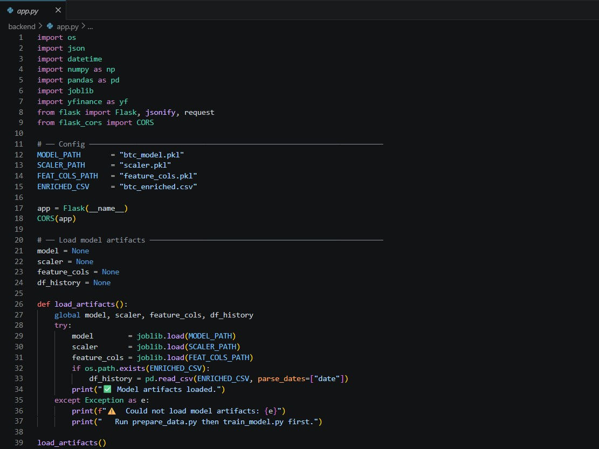

Helpers
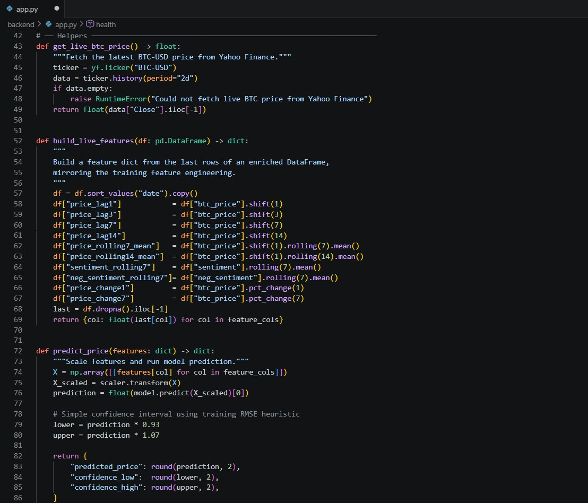

Router
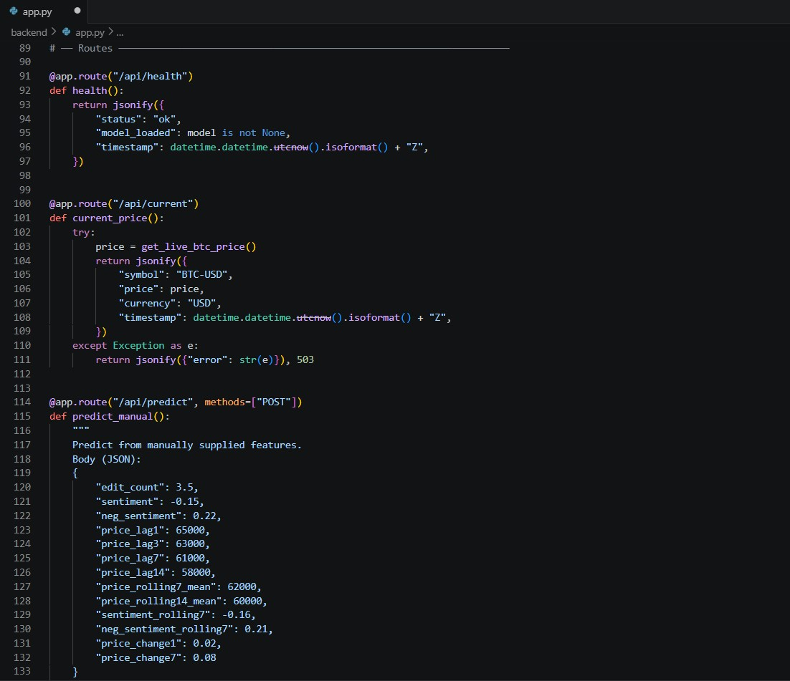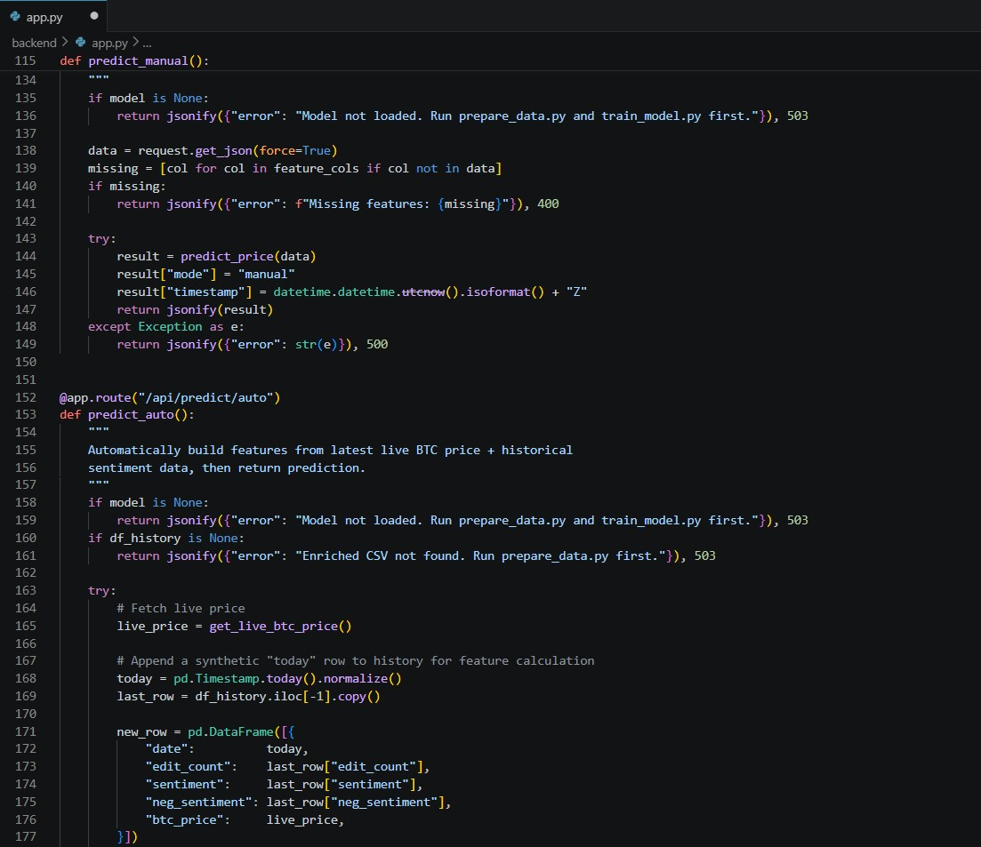
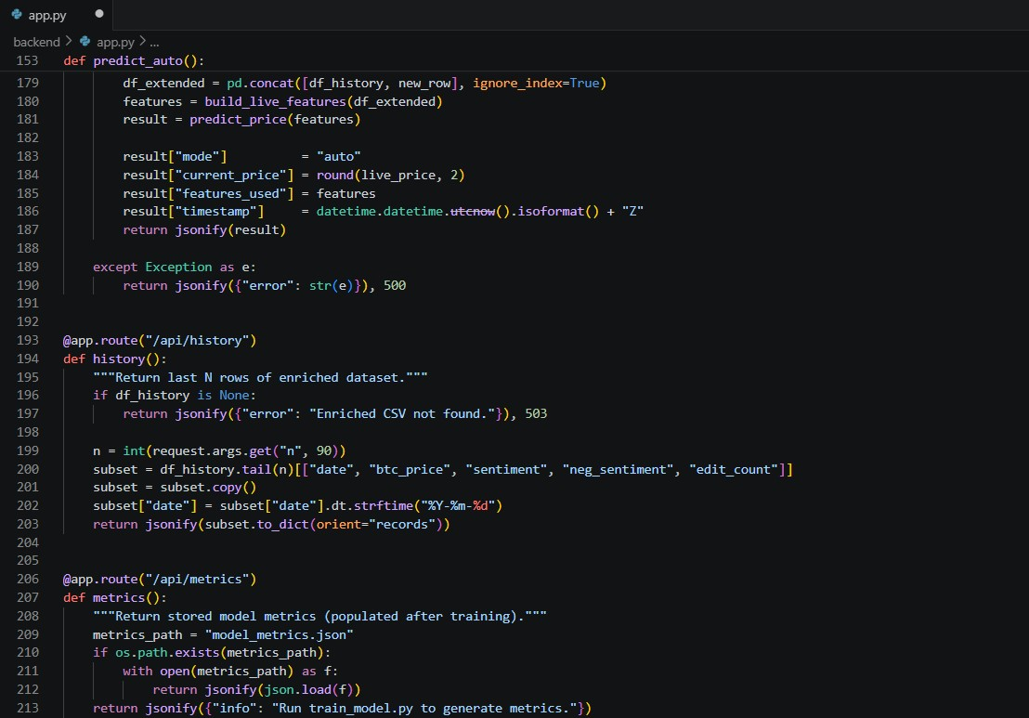
Main
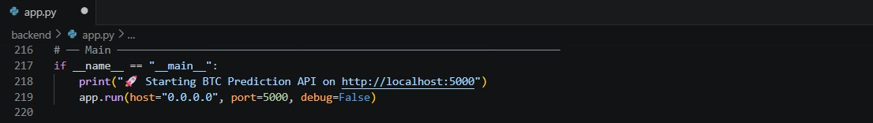

Prepare_data.py
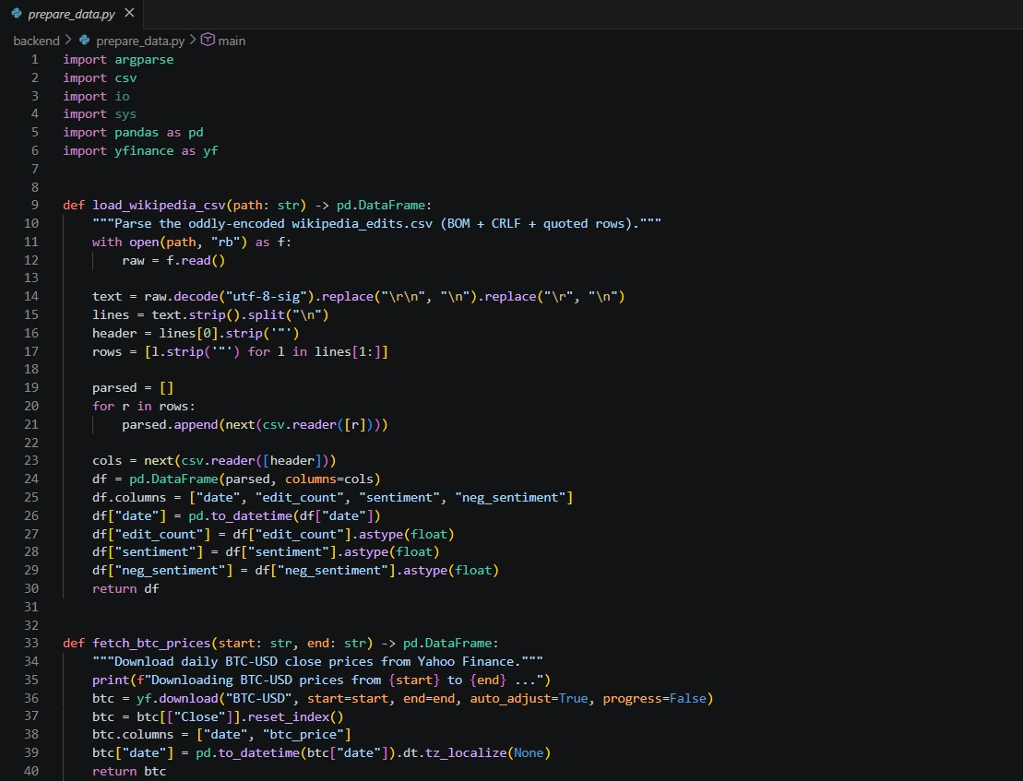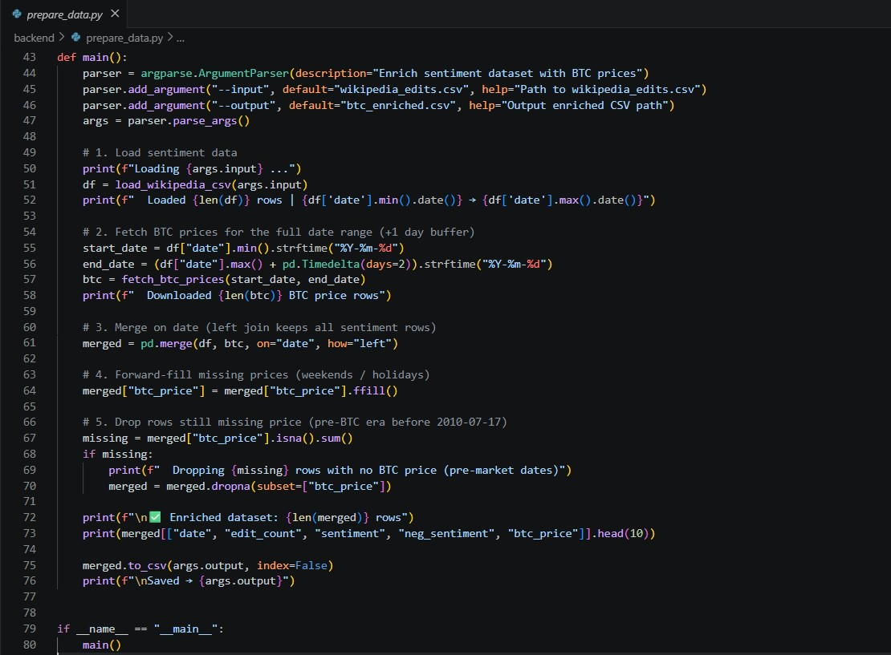

train_model.py
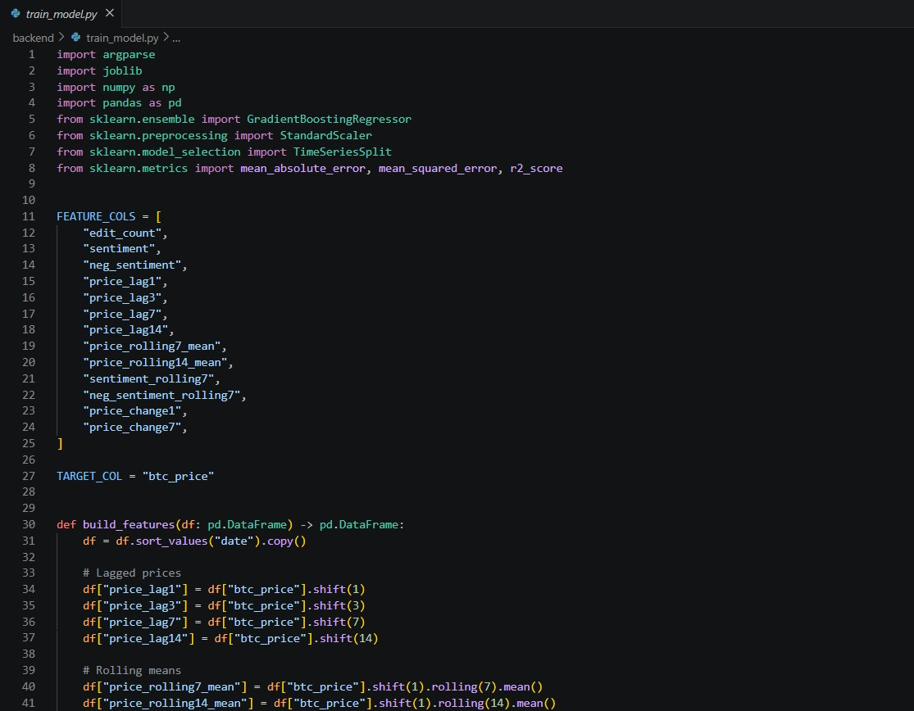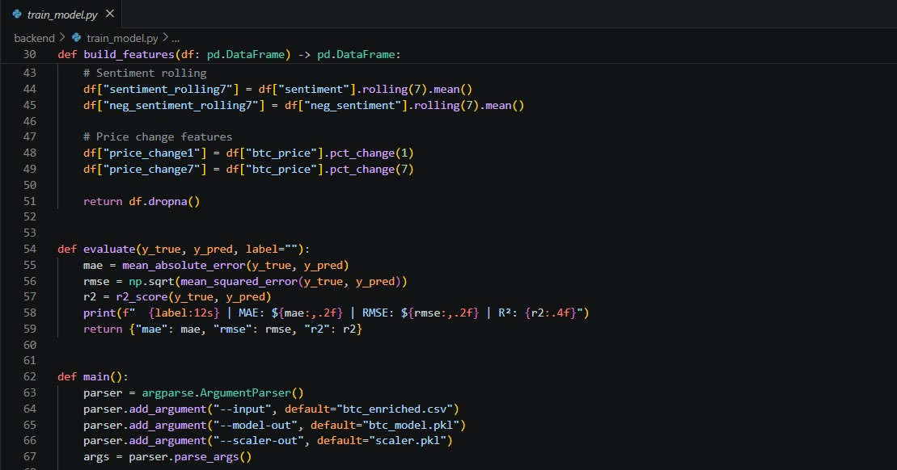

Load & feature-engineer
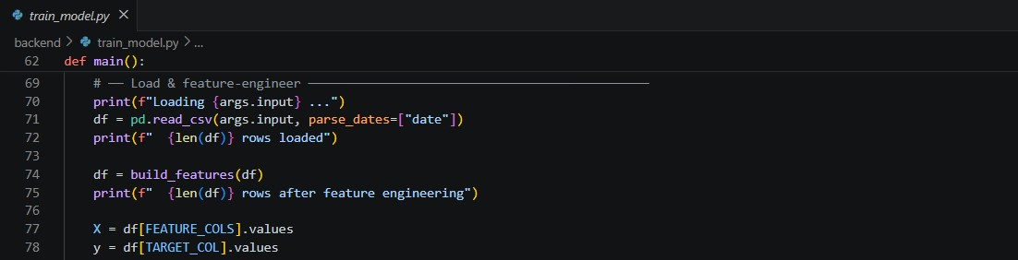

Scale features
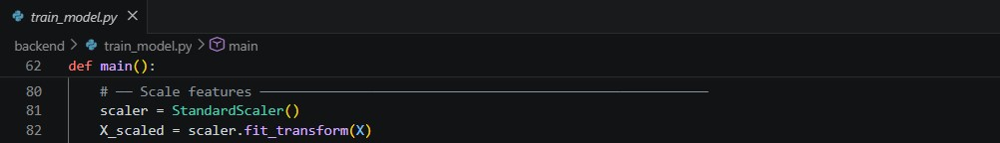

Time-series cross-validation
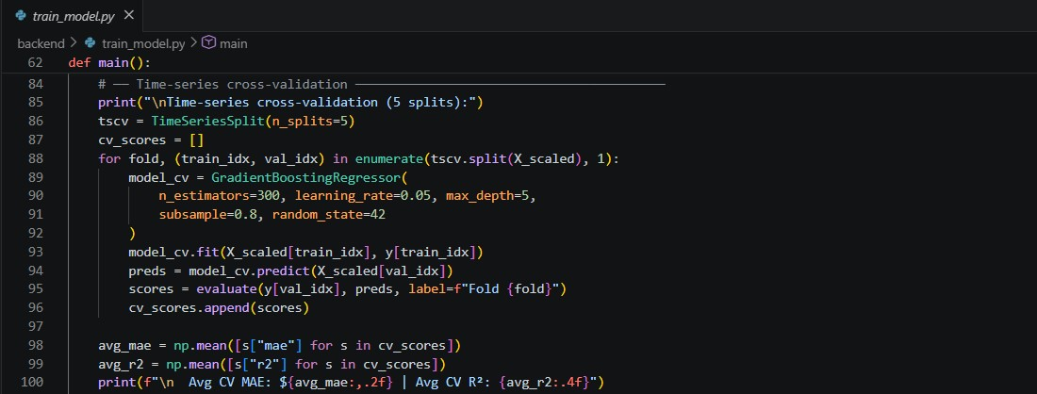

Train final model on all data
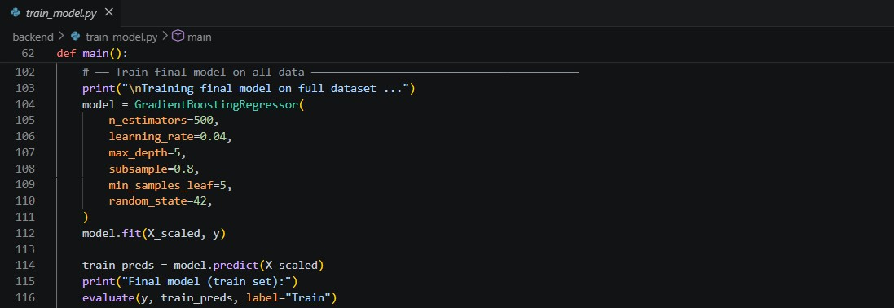
Feature importance
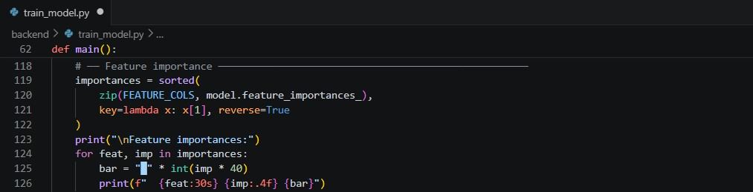
Save model & scaler
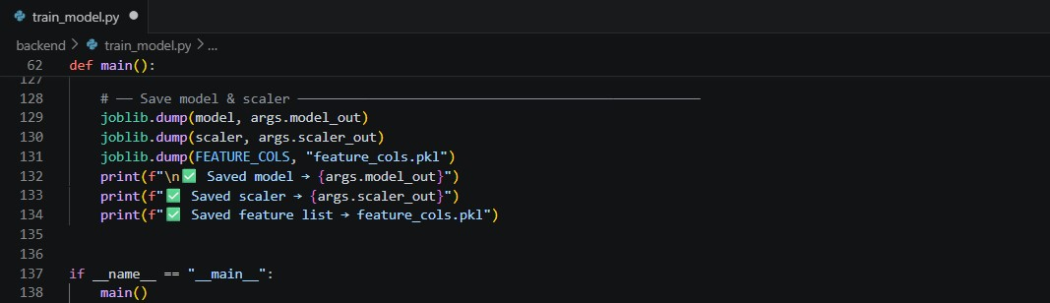

Index.html
Animated grid bg
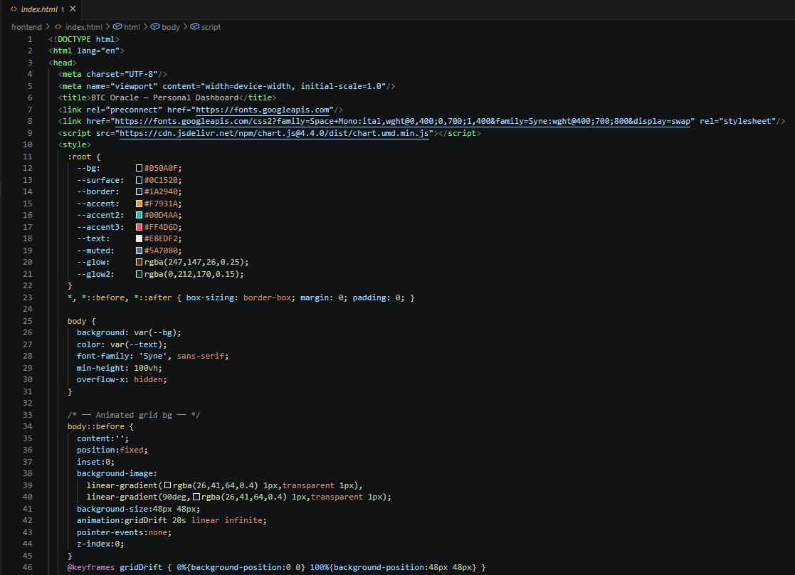

Login Page
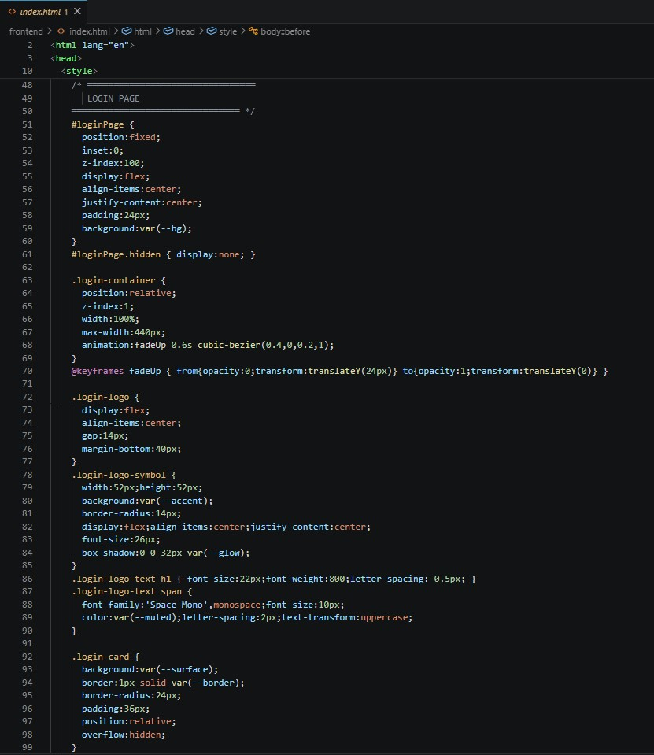

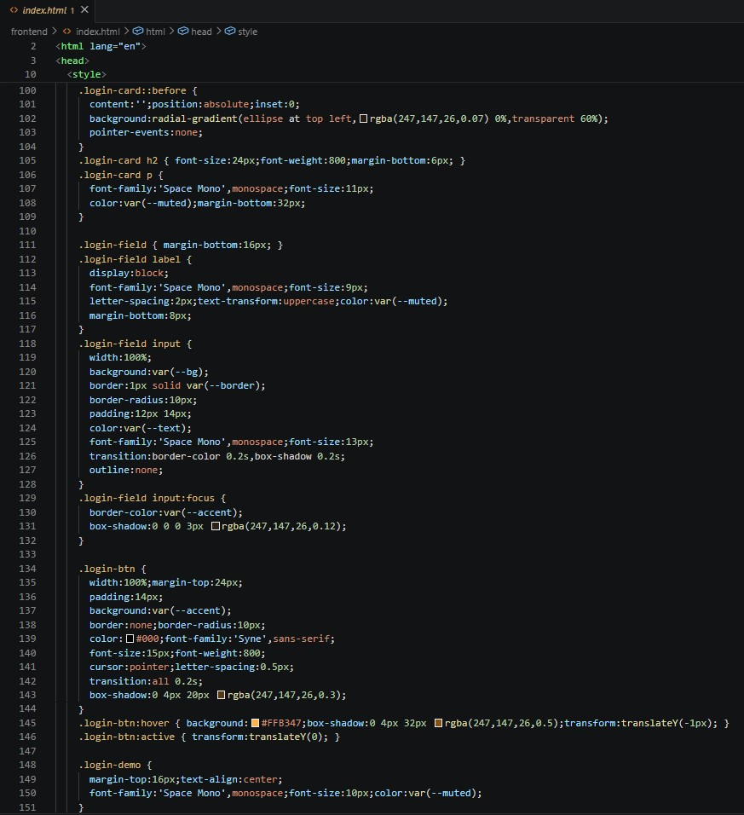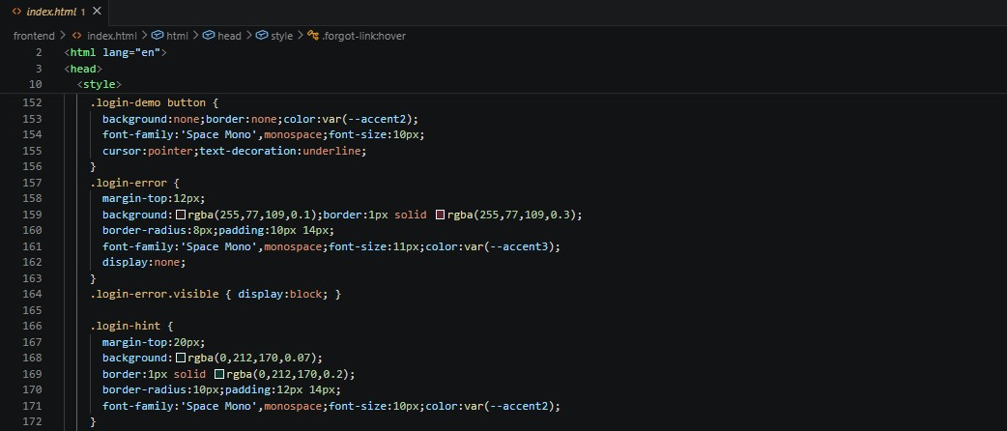

Main App
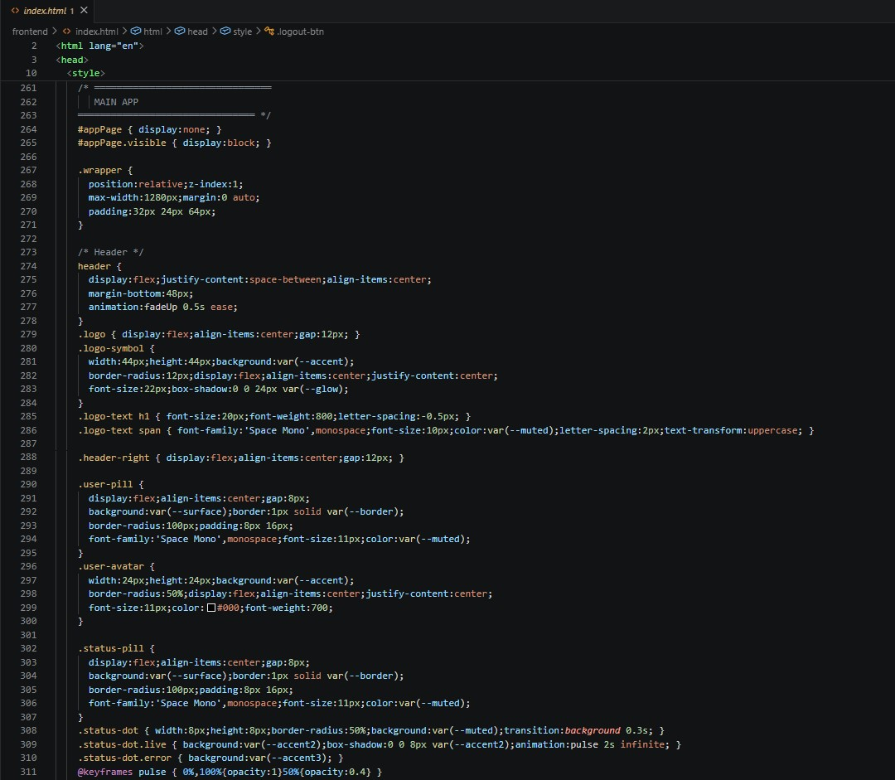

Portfolio bar
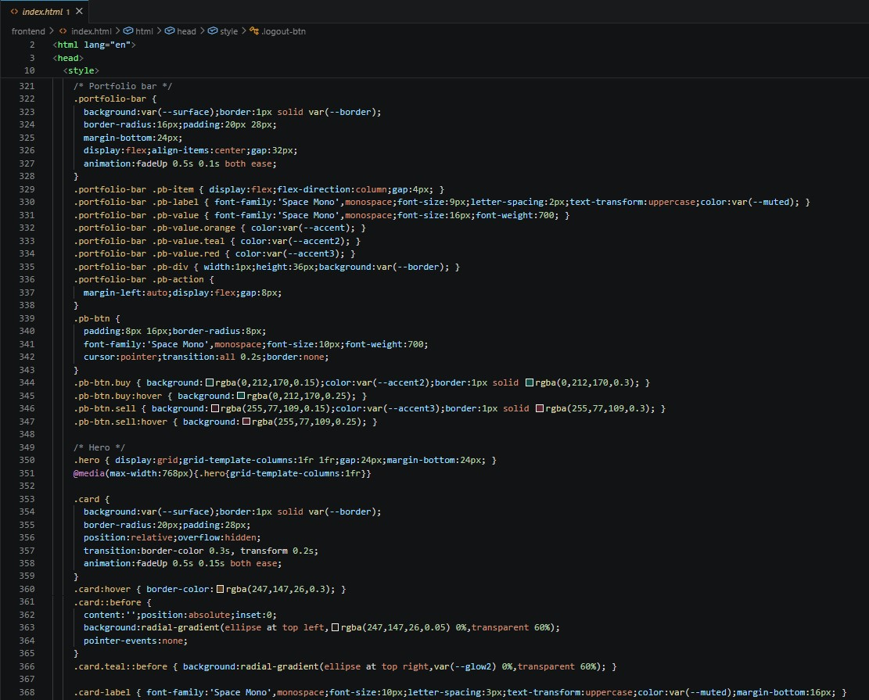

Tabs
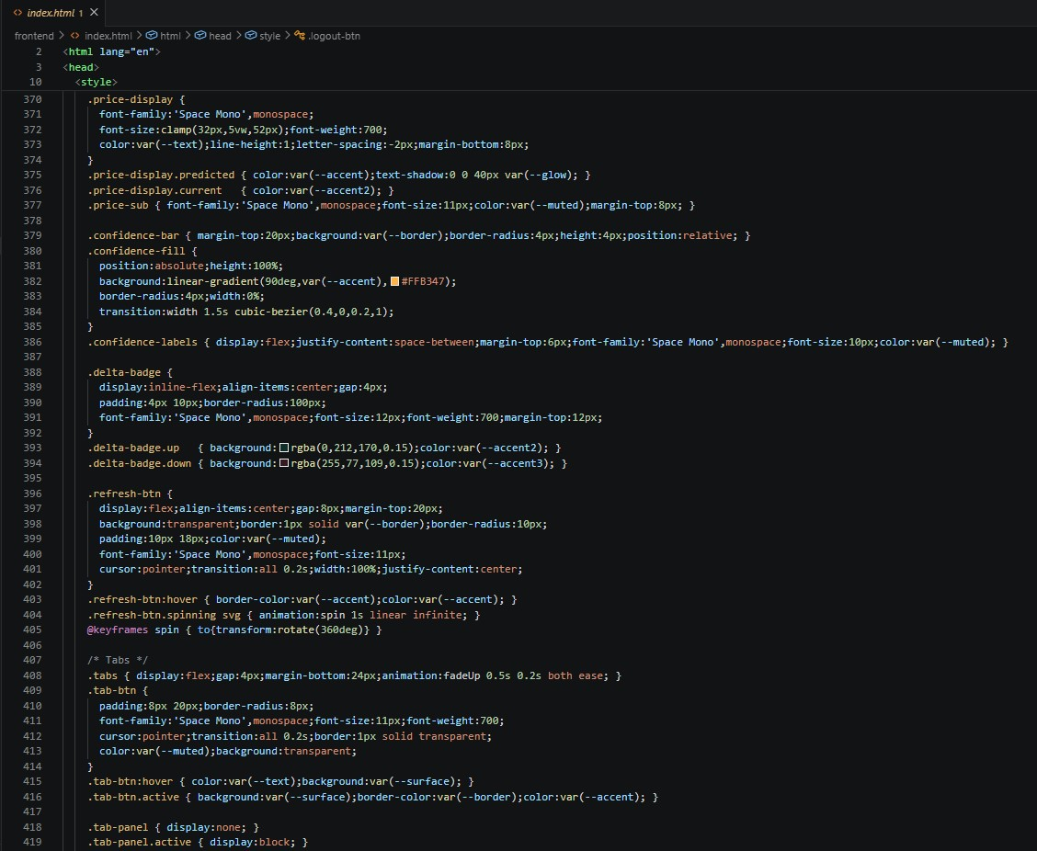

Chart, Bottom Grid, Form Card
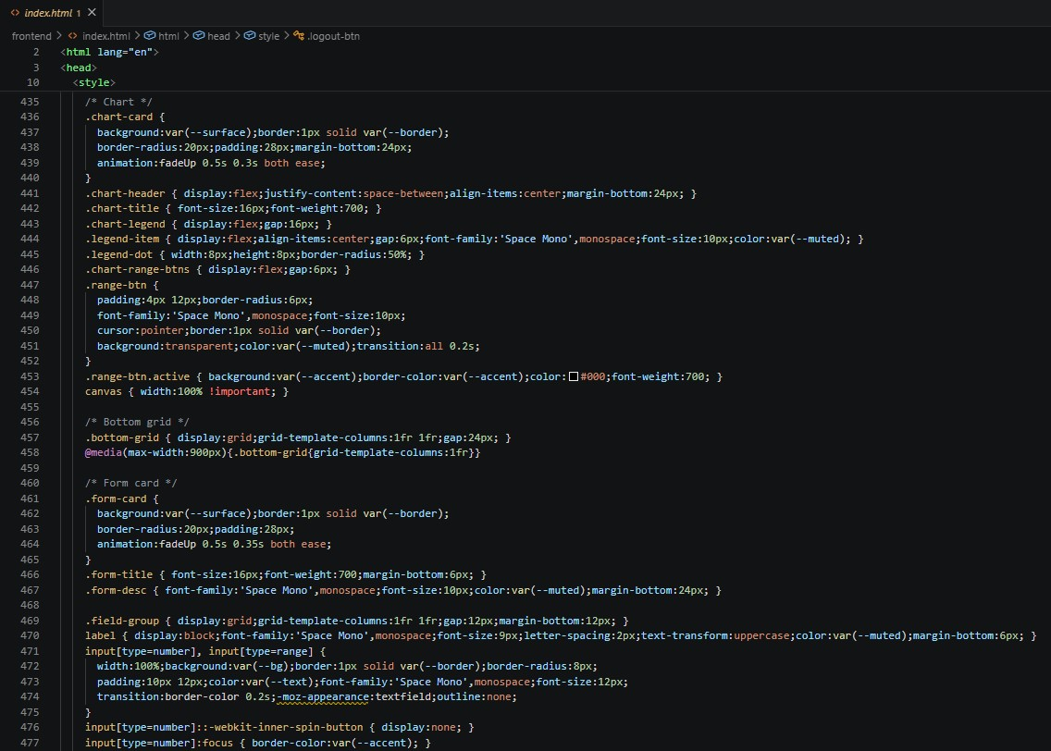
Sliders
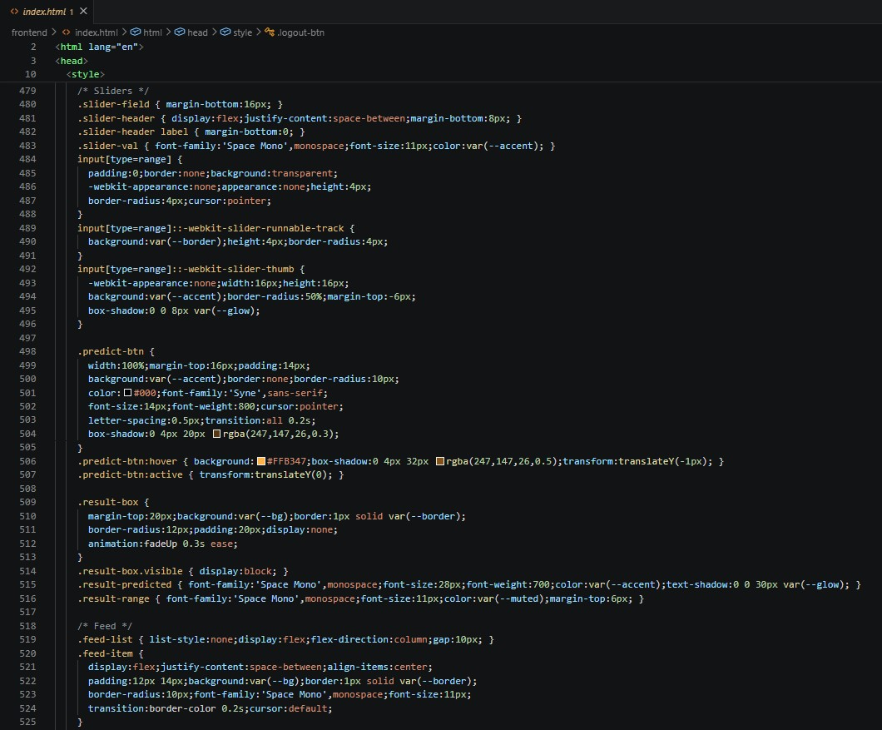
Alerts panel, Notes
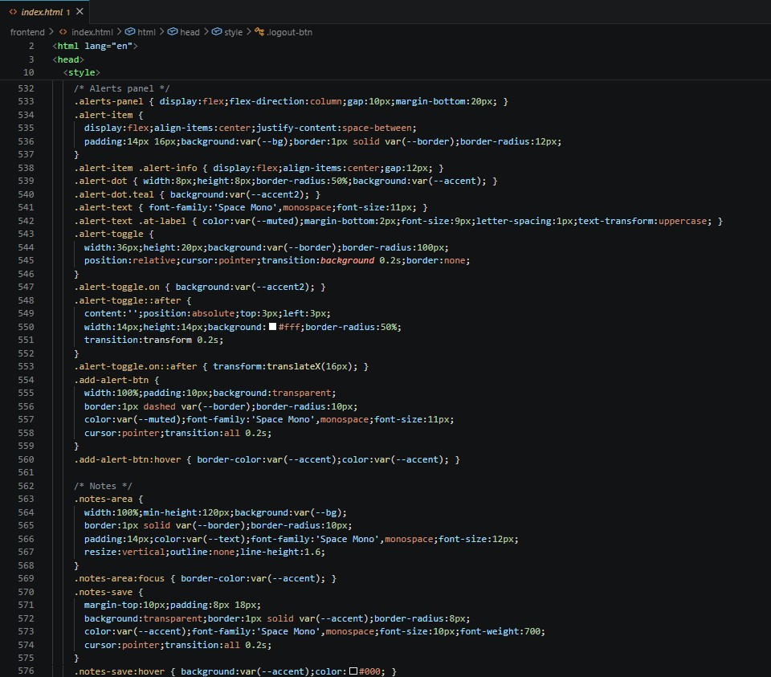

Auto Refresh
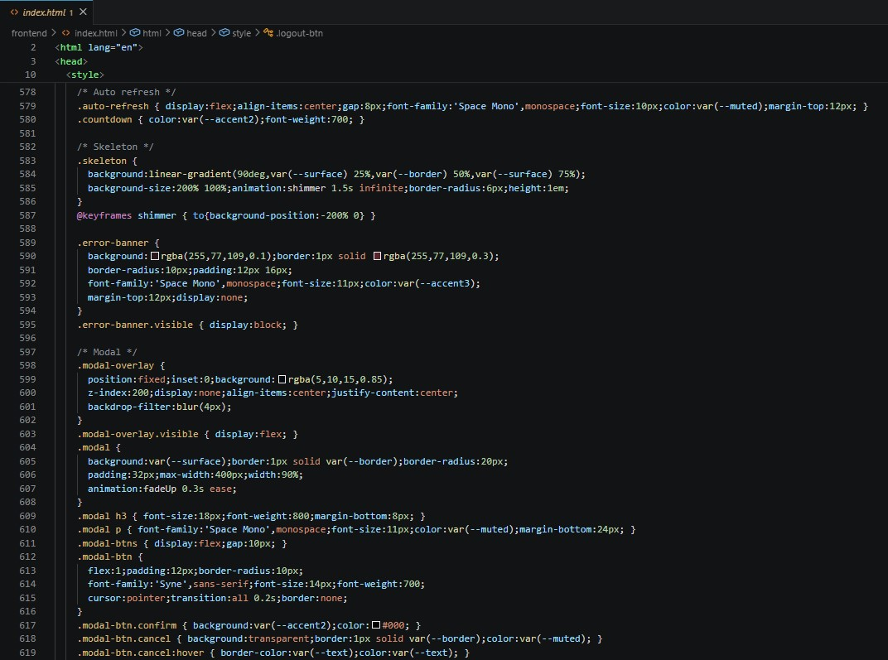

Toast
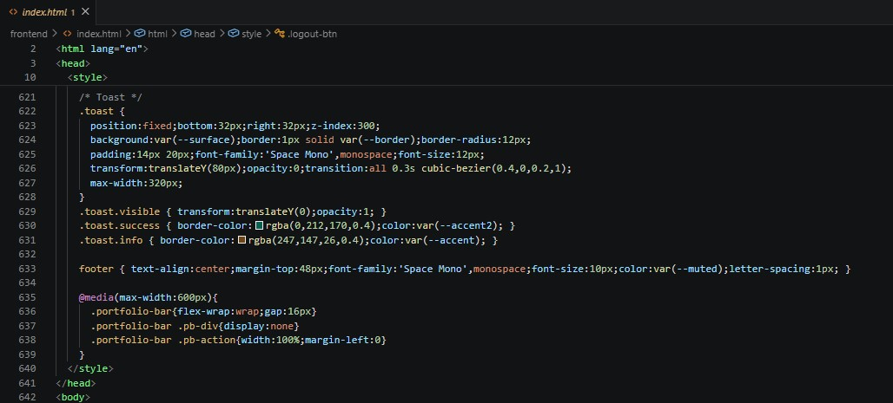

Login Page
Tab Switcher, Sign in panel
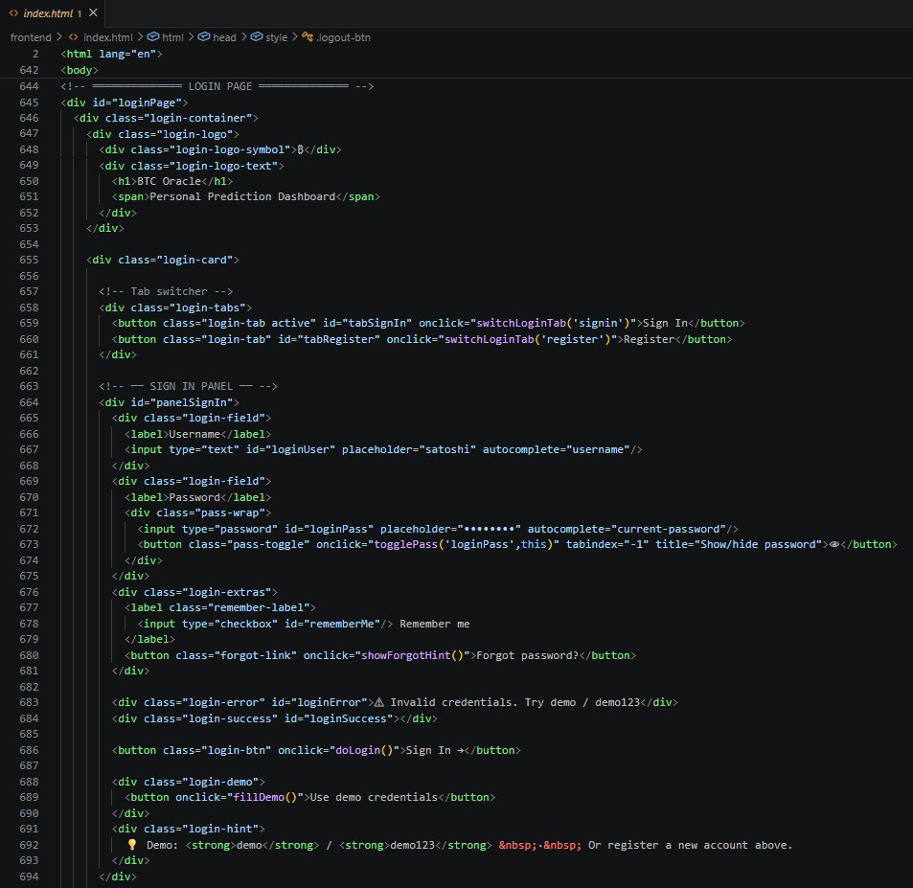

Register panel
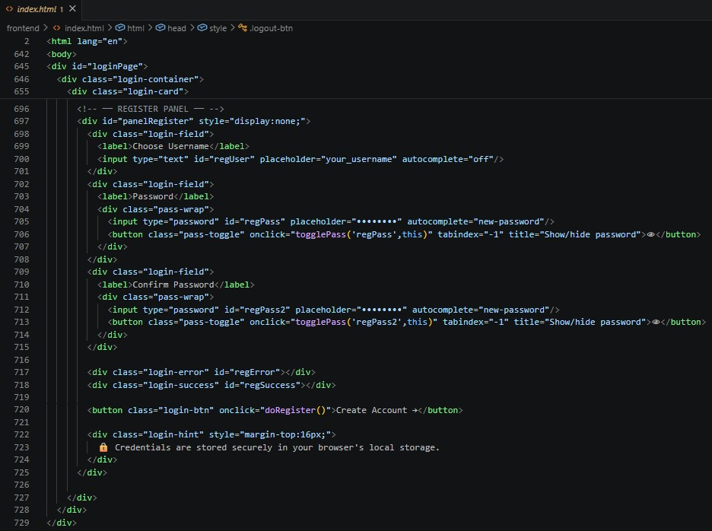

Main App
Portfolio bar
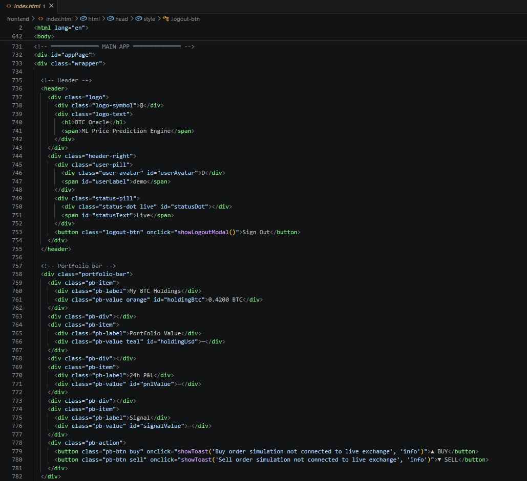

Dashboard Tab
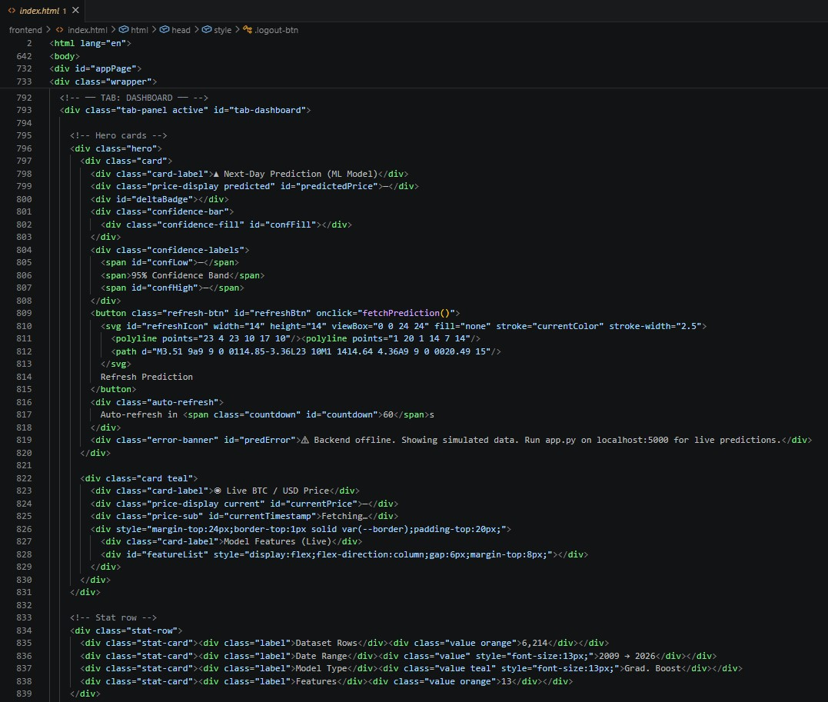

Charts
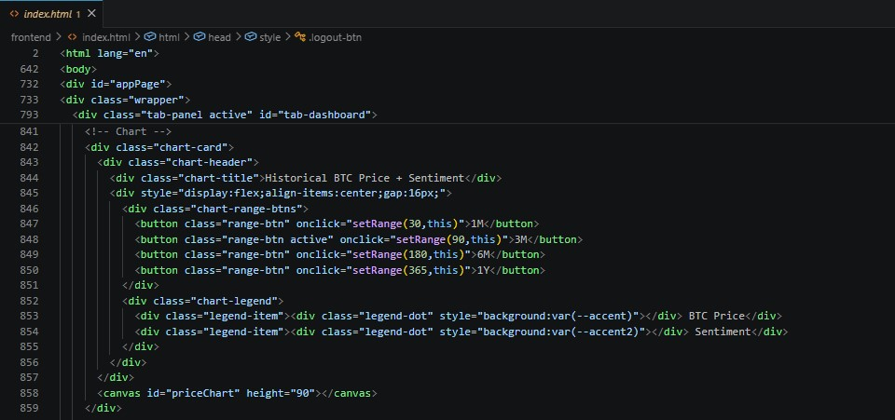

Simulator Tab
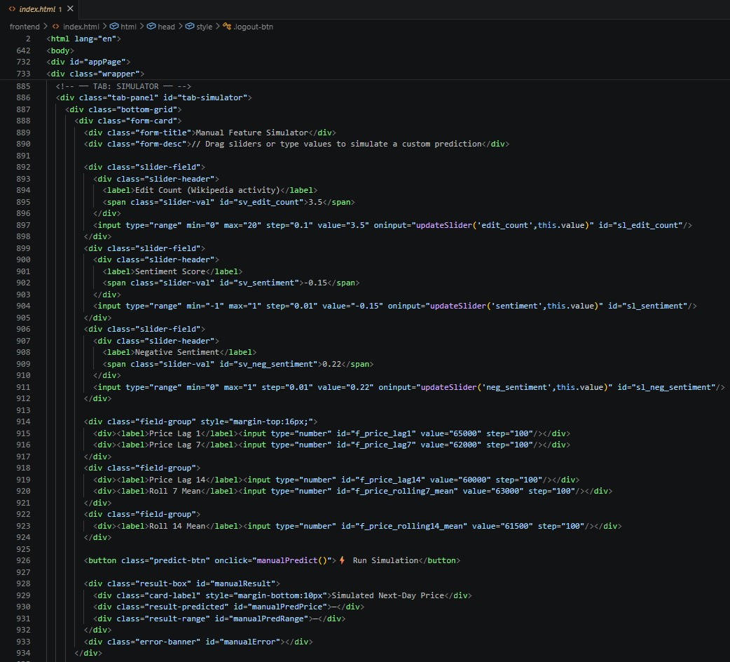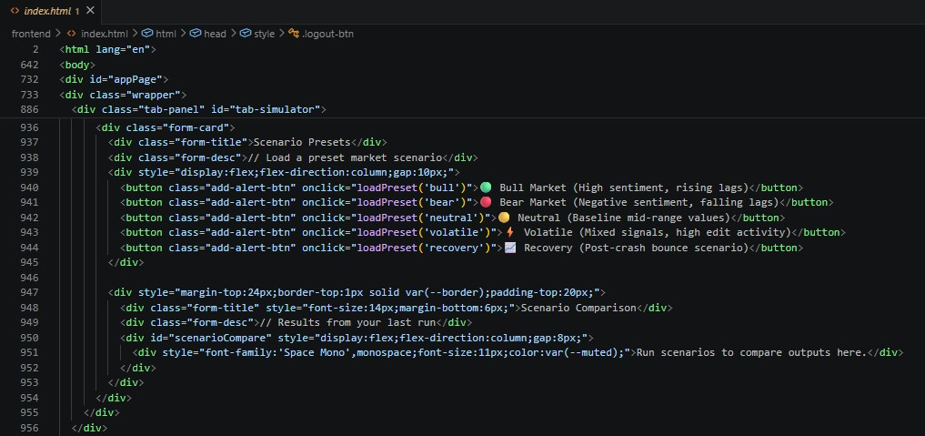

Alerts Tab
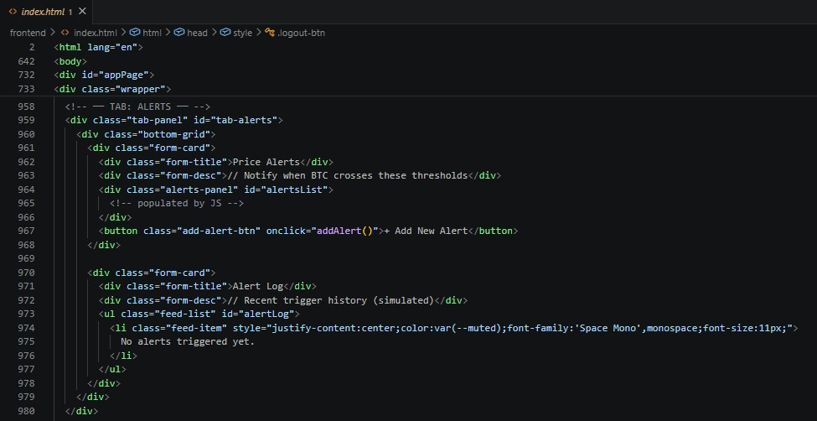

Notes Tab
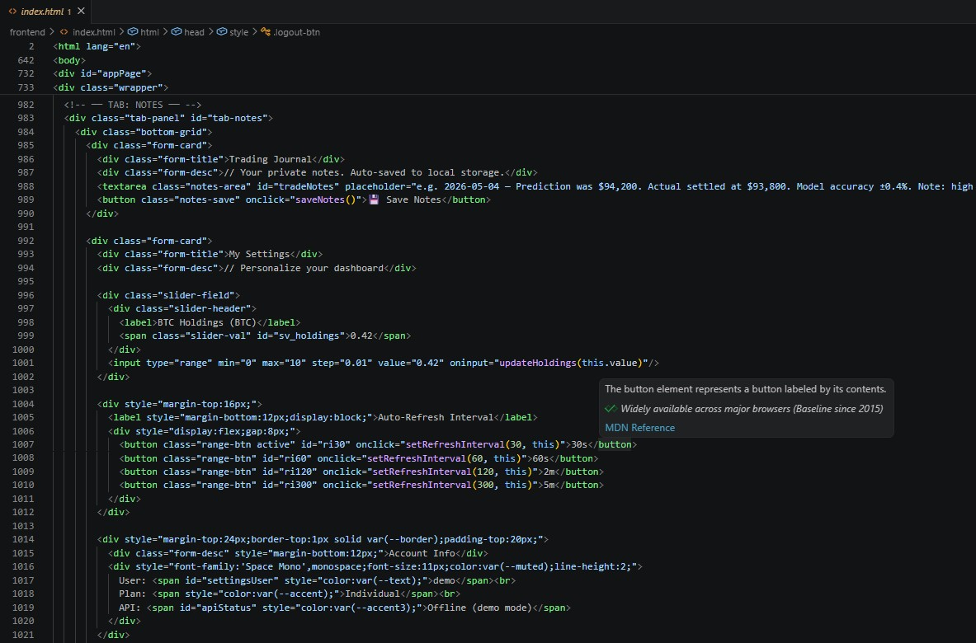

Logout Modal
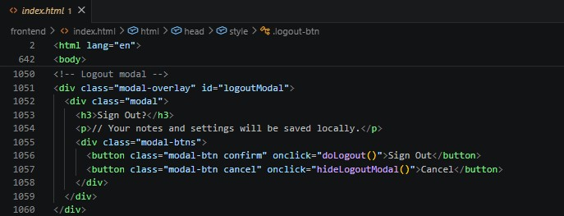

Tab switching, Password visibility toggle, Forgot password hint
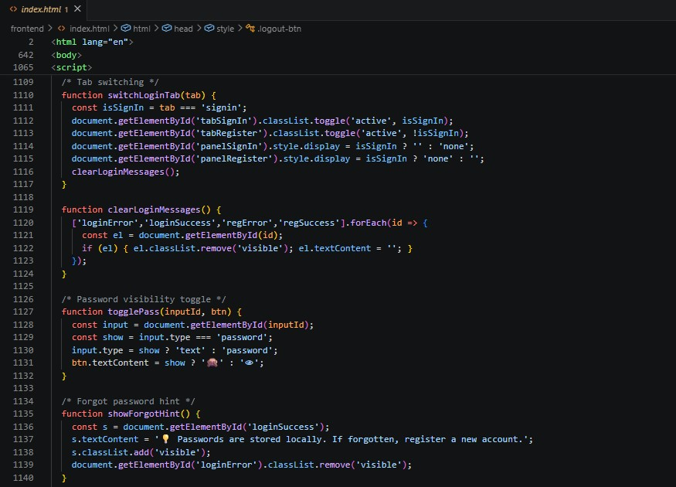

Register
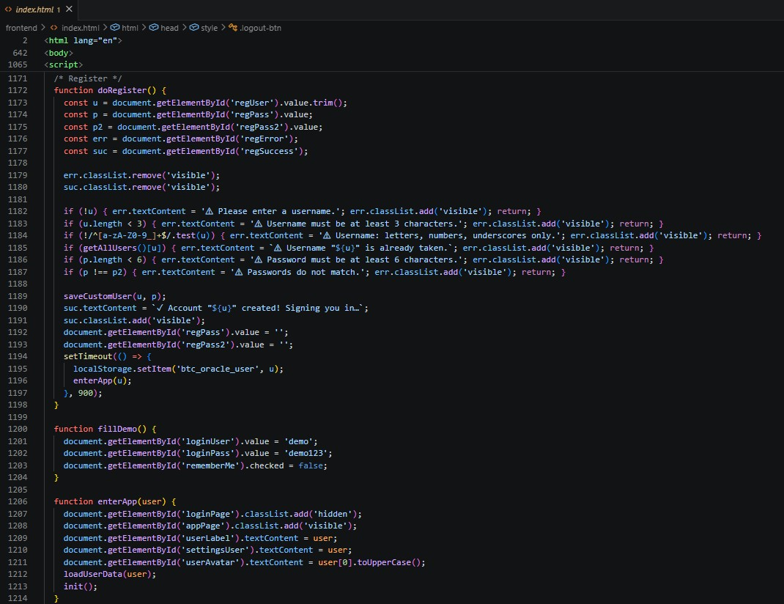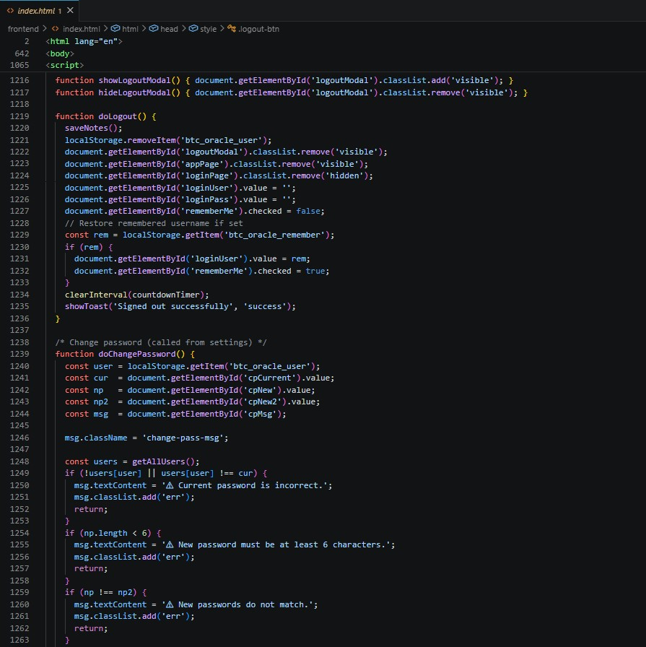
User Data
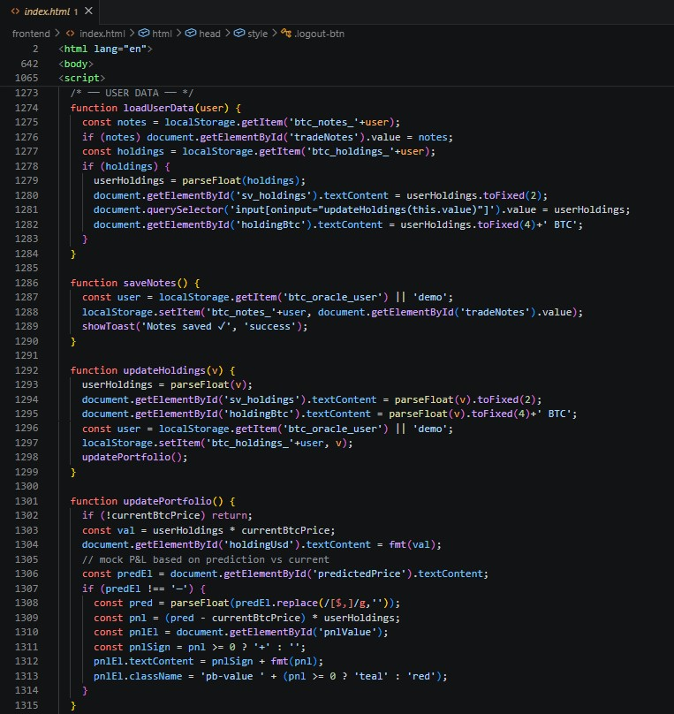

Feed
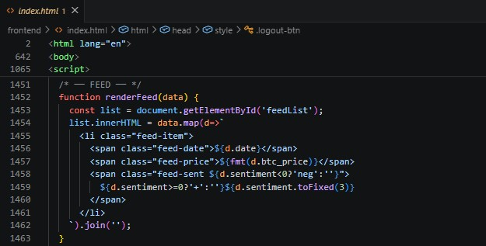
Prediction
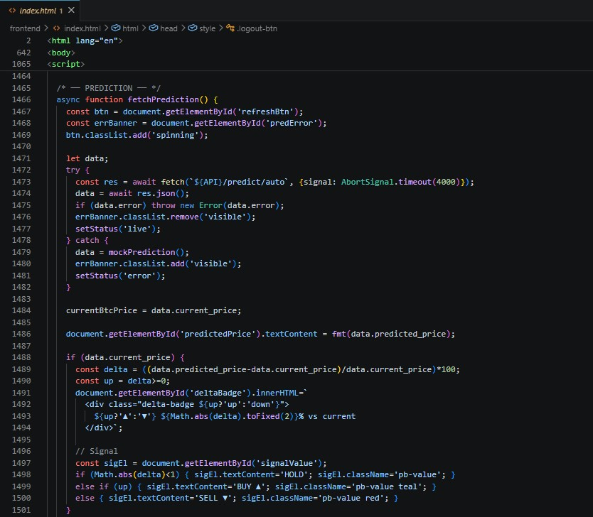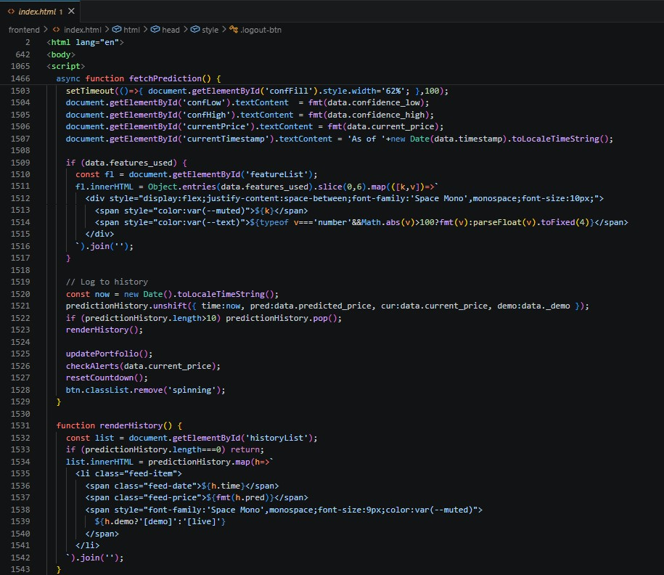
Manual prediction
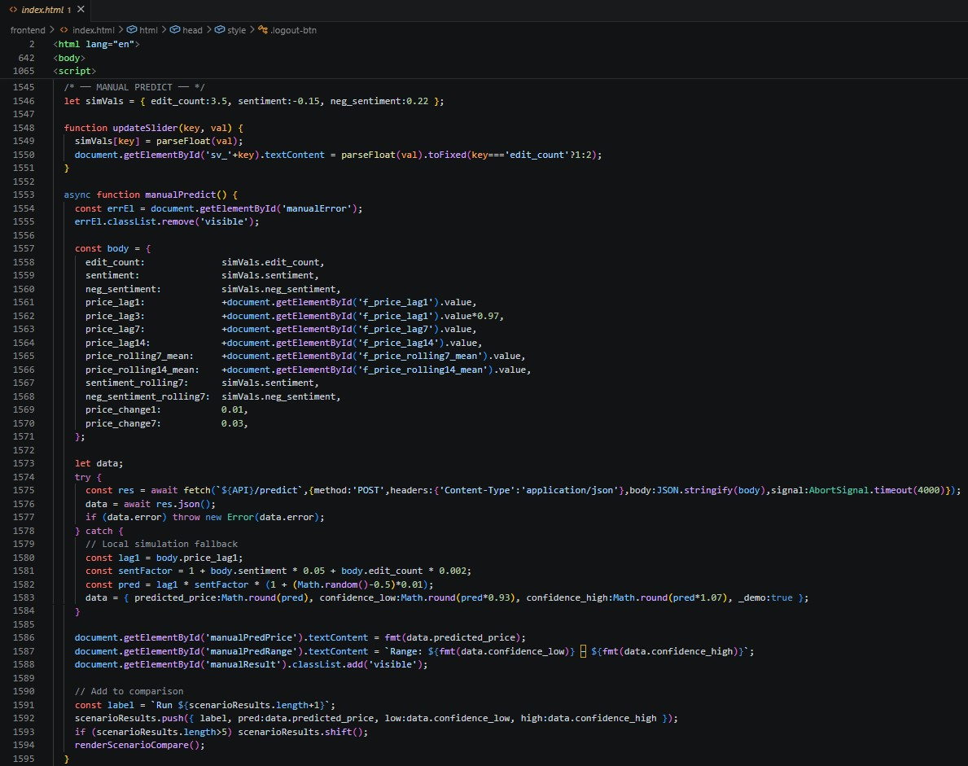

Presets
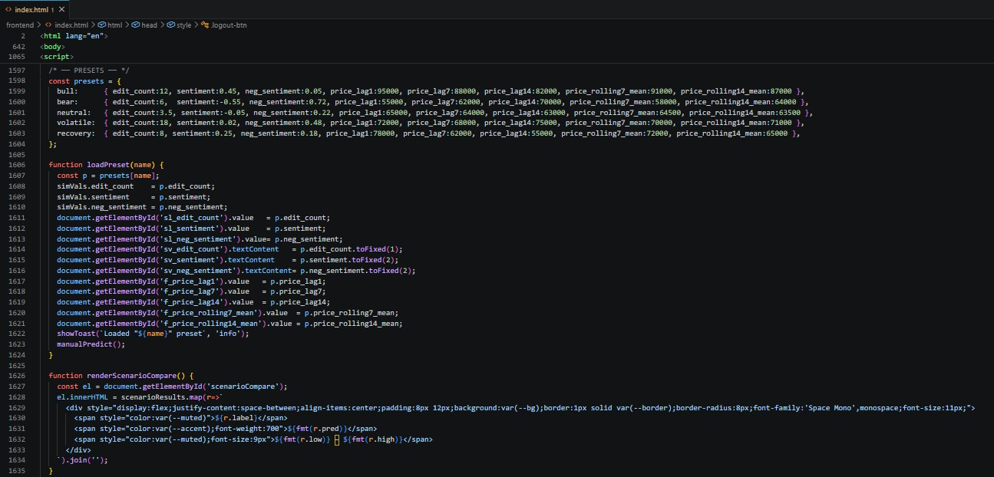
Alerts
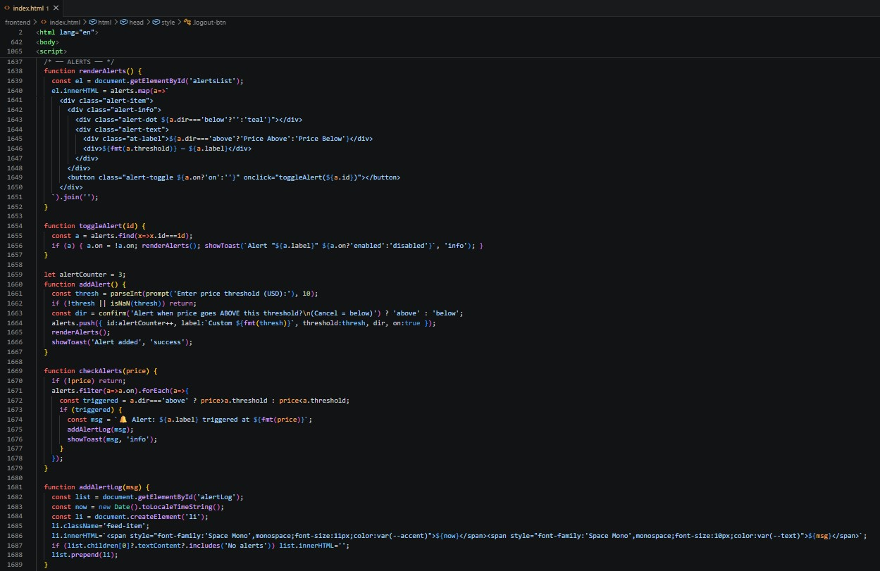

Countdown + Refresh Interval
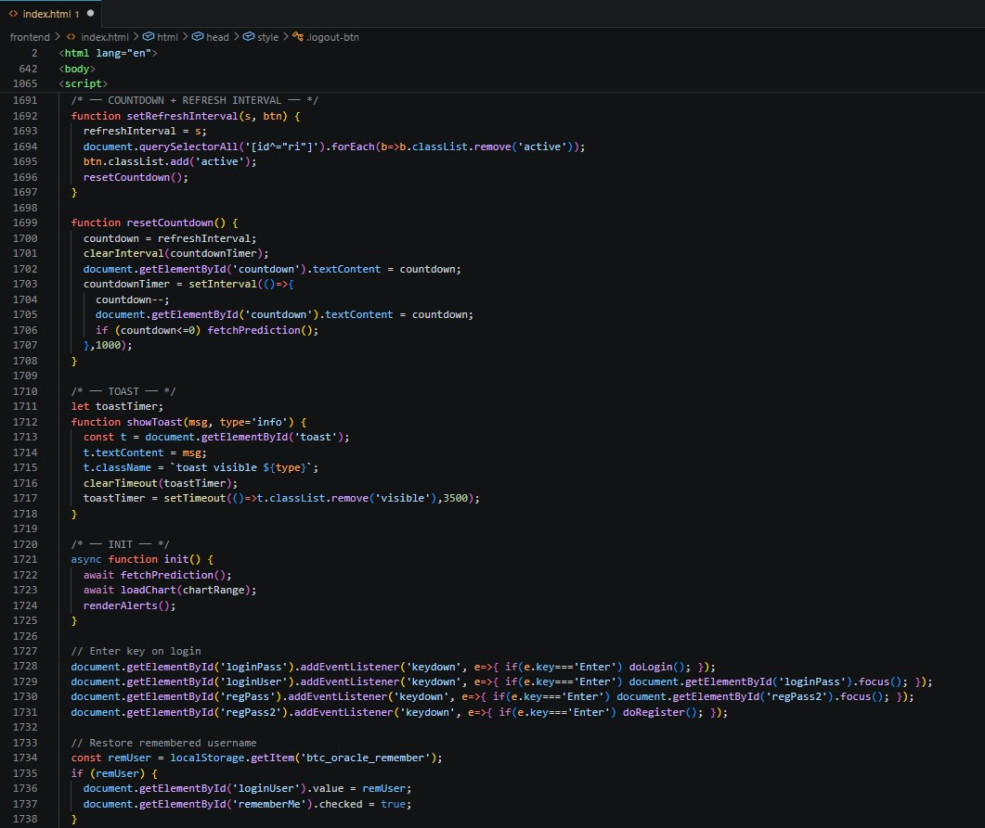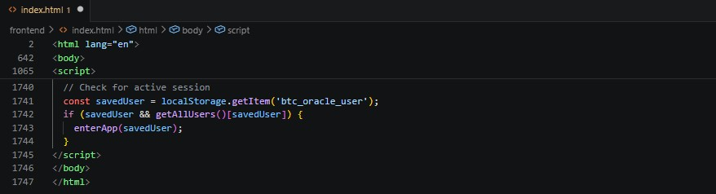

APPENDIX – II FINAL RESULTS

Registration Page
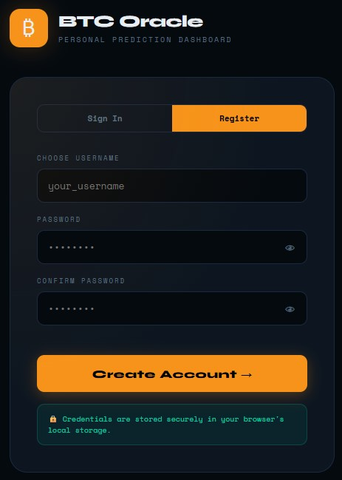

Sign In Page
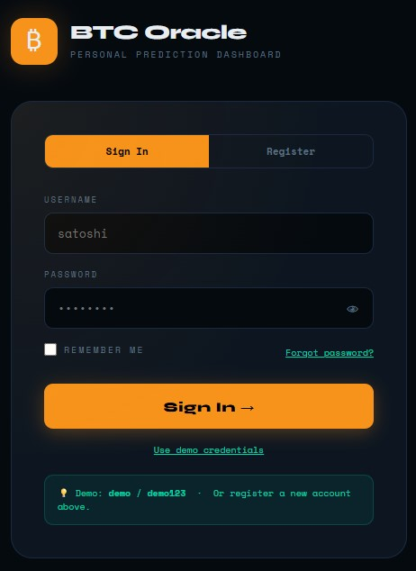

Dashboard
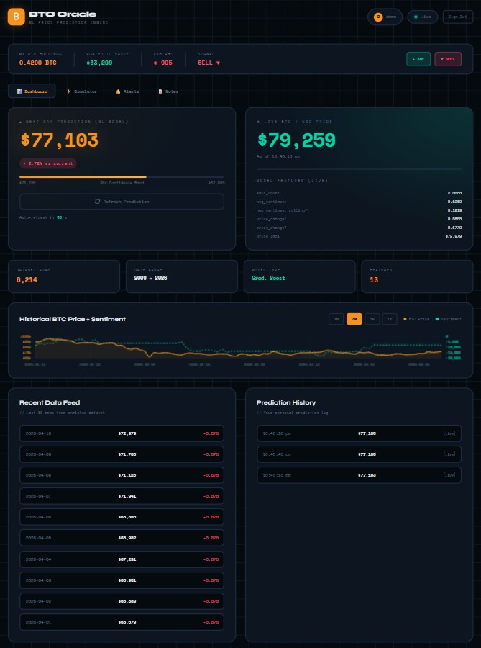

Simulator
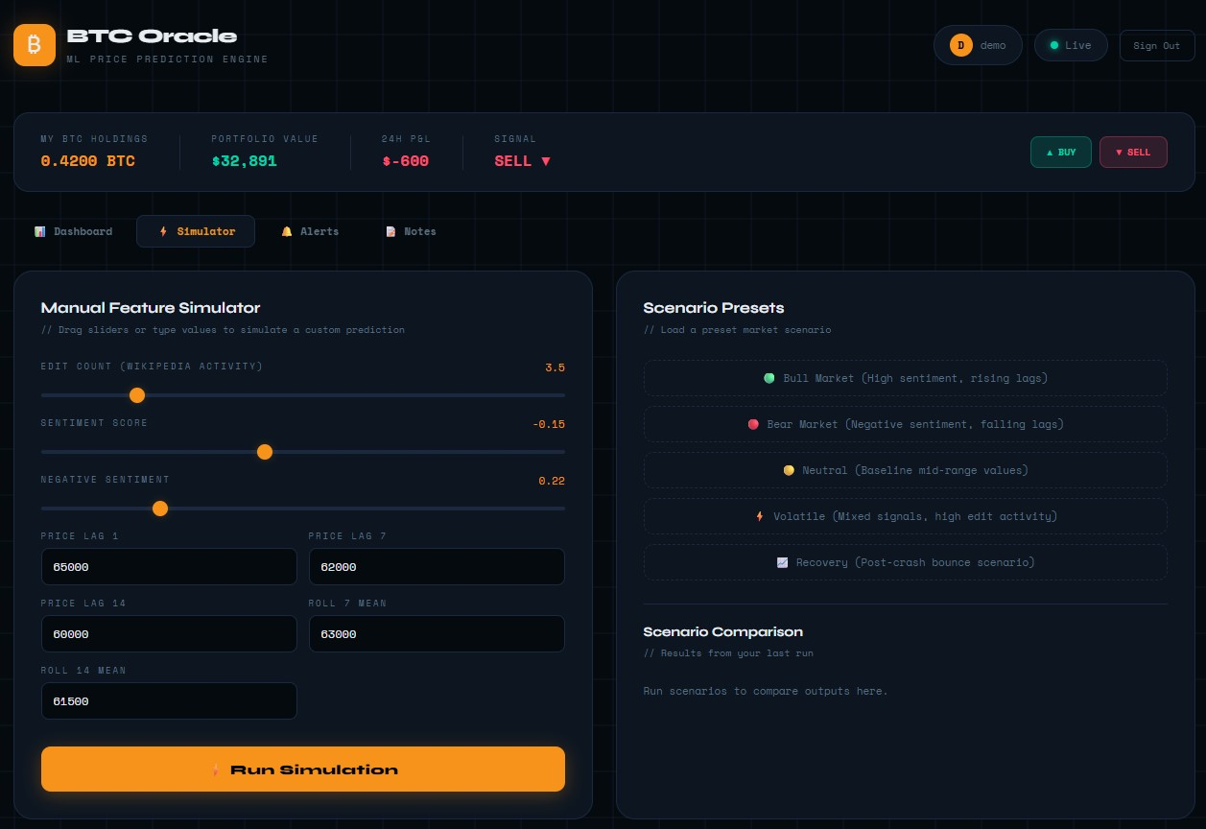

Alerts
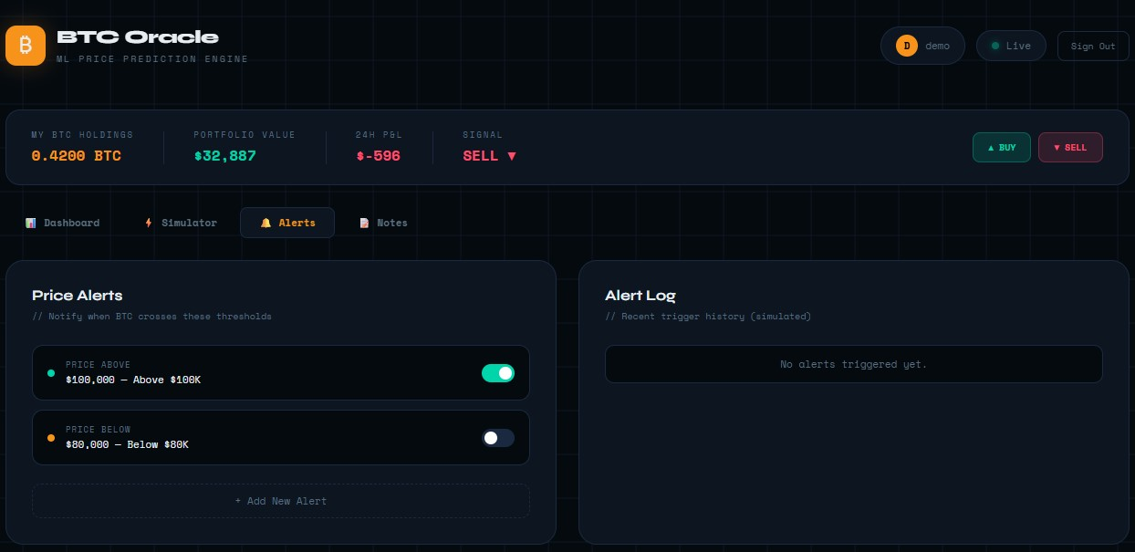

Notes
